x86 PROCESSOR MODES OF OPERATION: THE CPU'S DIFFERENT HATS

Let’s begin from the frontlines of CPUs that are in the market.

**⚙️** What is x86?

**x86** is the **instruction set architecture (ISA)** — aka the low-level “language” — that your CPU understands.

It started with Intel’s **8086** processor in 1978, and all its descendants (8088, 80286, 80386, etc.) stuck to this architecture — hence the name "x86".

Think of x86 like **the blueprint of how to speak to a CPU** — how to run instructions like MOV, ADD, INT, and all those.

**So, when you say:**

*"This app runs on x86"*

**You're saying:**

*"This app is made to run on a CPU that understands the 8086-style instruction set."*

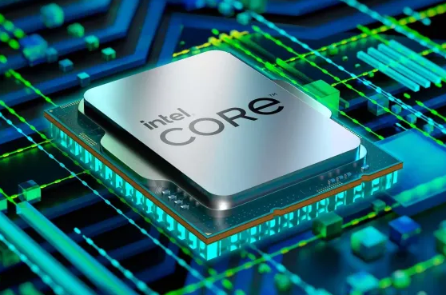

**🔥** What is AMD?

**AMD (Advanced Micro Devices)** is a **company**, like Intel.  
They make CPUs. But... here's the plot twist:

Back in the day, **AMD cloned Intel’s x86 chips** (legally, through a licensing agreement), and later *developed their own* x86-compatible processors.

So, basically:

* *AMD builds CPUs that speak the x86 language.*
* *So does Intel.*
* *They are different brands, but they run the same kind of machine code.*

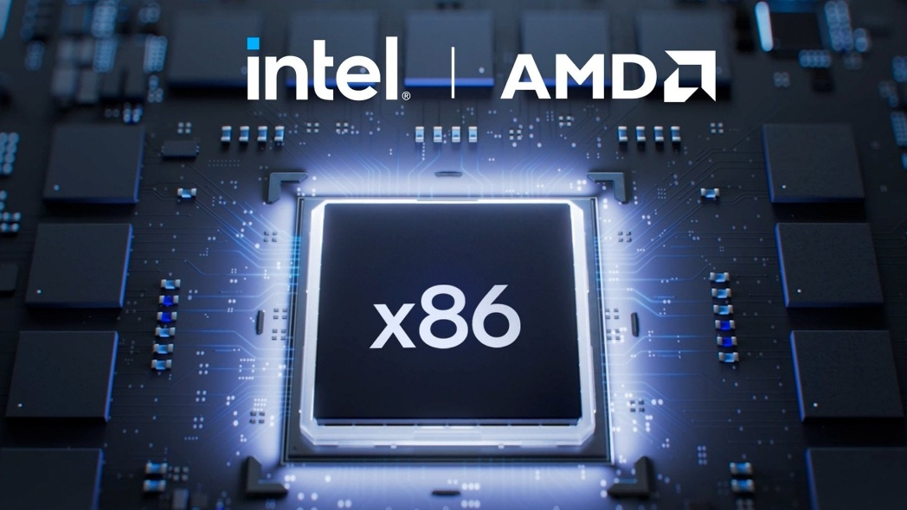

**🧠** So, Why the Confusion?

Because of this:

* *When people say “x86”, they often mean Intel-style CPUs in general (Intel or AMD).*
* *And when AMD released the first 64-bit x86 CPUs, they called the extension x86-64.*
* *Sometimes called AMD64 — which further confuses people.*

**🤯** Real Talk: So…

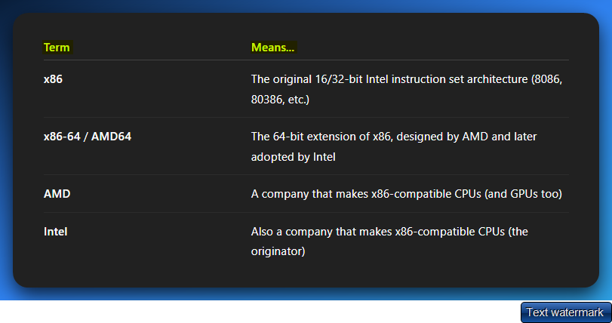

**⚔️** Who Wins?

Both AMD and Intel make x86 CPUs.

But AMD *designed* the 64-bit version first (x86-64), and Intel just adopted it (after failing with their own 64-bit attempt called IA-64).

**So yeah:**

🔥 *AMD gave birth to the modern 64-bit x86 you use today. Intel had to catch up.*



**🧠** x86 PROCESSOR MODES — THE CPU’S WARDROBE CHANGE

Your CPU isn’t stuck wearing one outfit. It’s got **multiple modes**, and each one changes *how it behaves*, *what it can access*, and *what it’s allowed to do*.

These “modes” control things like:

* 🔐 **Who has privilege** (OS or app?)
* 🧠 **How memory is addressed** (flat vs segmented, 20-bit vs 32-bit vs 64-bit)
* 🧾 **Which instructions are valid** (some modes unlock advanced features)

Basically, **the mode defines the rules of the world the CPU lives in**.

**🏛️** Why So Many Modes?

Over time, as systems evolved from:

* 🪦 Simple MS-DOS single-tasking
* → 🧩 Multitasking OSes (Windows, Linux)
* → 🛡️ Secure kernel-user separation
* → 🧙 Virtualization and emulators

…Intel had to keep adding new hats (modes) to let the CPU play nice with all these roles. Instead of wiping out old tech, they just **layered the new stuff on top**.

So yeah — we got **Real Mode, Protected Mode, Long Mode, SMM, VMX**, and more.

**🧑‍💻** Who’s in Charge?

The **Operating System (OS)** is the one flipping the mode switches behind the scenes. You, as the programmer or reverse engineer, are seeing the effects — but it's the OS that goes:

*“Alright, flip to Protected Mode. I need privilege levels and memory protection now.”*

**Or:**

*“Booting up? Cool, let's start in Real Mode, do some BIOS work, then shift into the real stuff.”*

**🐍** Malware Angle

Why do you care?

**Because malware loves playing mode games. It might:**

* *Switch to Real Mode or SMM to bypass protections.*
* *Use Ring 0 tricks in Protected Mode.*
* *Or abuse VMX (virtualization extensions) to hide inside fake hypervisors.*

Knowing the mode tells you **what kind of mischief is even *possible***.

**🧠** Real Mode — “The BIOS Brain”

**Real Mode** is the foundational operating mode of all x86 processors.

This goes back to the earliest Intel 8086/8088 processors used in the original IBM PC.

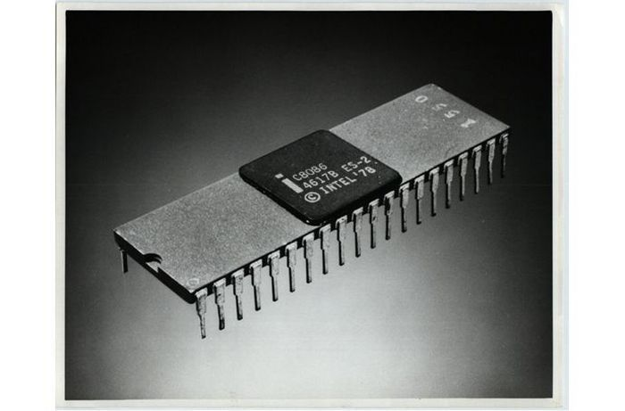

This mode isn't just a historical curiosity; it's the fundamental layer that every modern x86 system must traverse during its journey from power-on to full operation.

Every x86 CPU, regardless of its sophistication, awakens in Real Mode when power is first applied. This holds true whether you're working with:

* *A cutting-edge Intel Core i9 with billions of transistors.*
* *An AMD Ryzen with multiple cores and advanced features.*
* *A vintage 486 processor from the early 1990s.*
* *Even the most basic embedded x86 controllers.*

This universal behavior stems from Intel's unwavering commitment to backward compatibility—a design philosophy that ensures software written for the original IBM PC can theoretically still execute on modern hardware.

The Hardware Reset State

When an x86 processor exits reset, it enters Real Mode with a specific, well-defined state:

* **Instruction Pointer (IP)**: Points to address FFFF:0000 (the reset vector)
* **Segment Registers**: CS=FFFF, all others typically zero
* **Flags Register**: Cleared to a known state
* **Memory Model**: 16-bit segmented addressing active
* **Address Space**: Limited to 1MB (20-bit addressing)

This predictable startup state allows the BIOS/UEFI firmware to take control and begin the complex process of system initialization.

Why Real Mode Persists

The persistence of Real Mode in modern processors serves several critical purposes:

**Historical Compatibility**: Maintains the ability to run legacy software and operating systems that were designed for the original PC architecture.

**Boot Process Requirements**: Provides a simple, well-understood environment for firmware to initialize hardware components before transitioning to more complex operating modes.

**System Recovery**: Offers a fallback mode for diagnostic tools and recovery utilities that need to operate with minimal system complexity.

**Educational Value**: Serves as an accessible entry point for understanding low-level system programming concepts without the complexity of modern protection mechanisms.

**🔍** 1. Memory Model (aka the CS:IP Magic Trick)

🧱 Breaking Away from Flat Memory

Modern 64-bit systems present memory as a single, continuous linear address space—imagine a long street where each house has a simple sequential number.

Real Mode operates fundamentally differently, using a **segmented memory model** that's more like a complex city divided into districts.

In this segmented world, you can't simply say "go to address 50,000." Instead, you must specify both:

* **Which district** (segment) you're targeting.
* **Where within that district** (offset) your destination lies.

🧮 Segmented Addressing (20-bit): The 20-Bit Address Generation Magic

Small reminder:



Segment Addressing is where Real Mode performs its most crucial trick: despite being built around 16-bit registers, it manages to address a full **1MB of memory space**.

This apparent contradiction is resolved through the segmented addressing formula:



Let's break this down with a concrete example:

* **Segment**: 0x1000 (stored in a segment register like CS, DS, ES, or SS)
* **Offset**: 0x0042 (stored in an offset register like IP, SP, SI, DI, etc.)
* **Calculation**: (0x1000 * 16) + 0x0042 = 0x10000 + 0x0042 = 0x10042
* **Result**: Physical address 0x10042

The Multiplication by 16: Why This Specific Number?

The multiplication by 16 isn't arbitrary—it's a clever bit manipulation:

* Multiplying by 16 is equivalent to shifting left by 4 bits - **24** bits.
* This transforms a 16-bit segment value into a 20-bit base address
* The shift creates 16-byte aligned segment boundaries (paragraphs)

**Example Visualization:**



*Let’s fix this part, I know you remember that SHL 4 means, everyone go 4 steps to the left.*

*And its crazy, coz this time, everyone goes 4 steps to the left, but why aren’t they dropping off as we discussed in the previous chapter?*

Example: If ax has this 16-bit value…





… would result in



ADDRESSING THE ORIGINS OF THE 20-BITS IN SEGMENT: OFFSET ADDRESSING OF OLD SYSTEMS

The journey into the depths of old x86 systems, especially their memory management, is a critical step for any reverse engineer or malware analyst.

It's a world where clever hardware tricks compensated for architectural limitations, leading to systems that are both foundational and, at times, maddeningly complex.

Let's peel back the layers of Real Mode, segment:offset addressing, and the Address Generation Unit (AGU).

The Genesis: Real Mode and the 8086/8088 CPU

Every x86 processor, from the venerable Intel 8086/8088 that powered the original IBM PC to today's multi-core behemoths, starts its life in **Real Mode** when it powers on.

This isn't because it's the most efficient or secure mode, but purely for *backward compatibility.* It’s like a grand old theater that always opens with a classic, even if it's showing a blockbuster later.



In the late 1970s, Intel designed the **8086/8088** as primarily 16-bit processors.

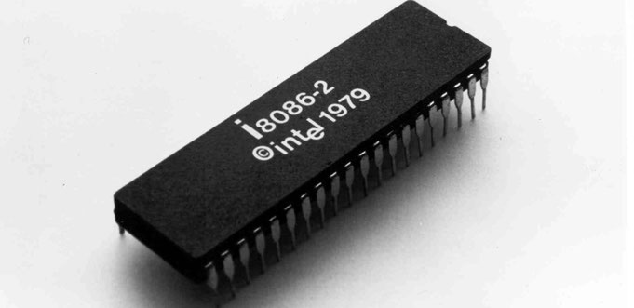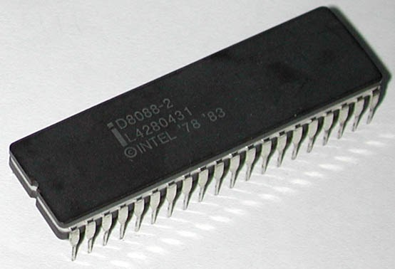

You can see their names and then their release years over here. These CPUs had internal registers (like AX, BX, CX, DX, SI, DI, BP, SP, IP) could only hold 16-bit values, capable of addressing 64 Kilobytes (KB) of memory directly (216 bytes = 65,535).

Intel’s ambition was greater: **early PCs** were designed to access 1 Megabyte (MB) of RAM (220 bytes). This created a dilemma: how do you access 1MB of memory with only 16-bit tools? Intel's answer was **segmented memory addressing**.

Real Mode's Characteristics: A Double-Edged Sword

**No Flat memory Addressing:** Unlike modern 64-bit systems that view memory as one continuous block (a flat memory model), Real Mode sees memory as segmented. Imagine a city divided into blocks, where each house needs both a block number (segment) and a house number within that block (offset).



**Direct Physical Access, Zero Protection:** In Real Mode, there is no memory protection. Programs talk directly to physical RAM; there's no virtualization, no page tables, no mapping layers. This was great for simplicity and speed but terrible for safety. A single rogue program could overwrite the operating system, smash other programs' memory, trash the BIOS, or crash the entire system. It's like giving everyone the master key to every door in a city.

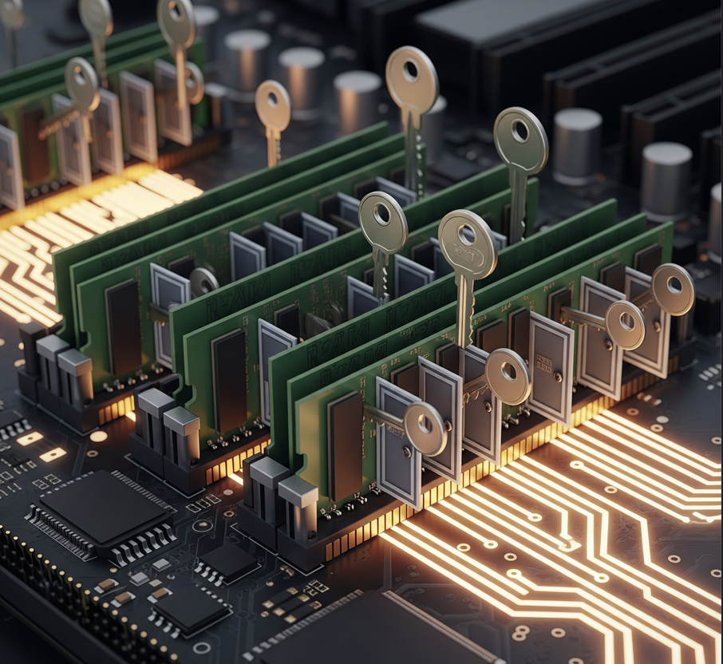

**No Privilege Levels (Ring 0 for Everyone):** In Real Mode, every program, from the BIOS to your 1988 Snake game, runs at Ring 0, the highest privilege level. There's no enforcement of privilege separation.



**16-bit Instruction Set Only:** Real Mode only supports the original 8086/8088 16-bit instruction set. This means no 32-bit instructions, no SIMD, no paging, and no privilege levels. It's vintage and lacks modern safety features.

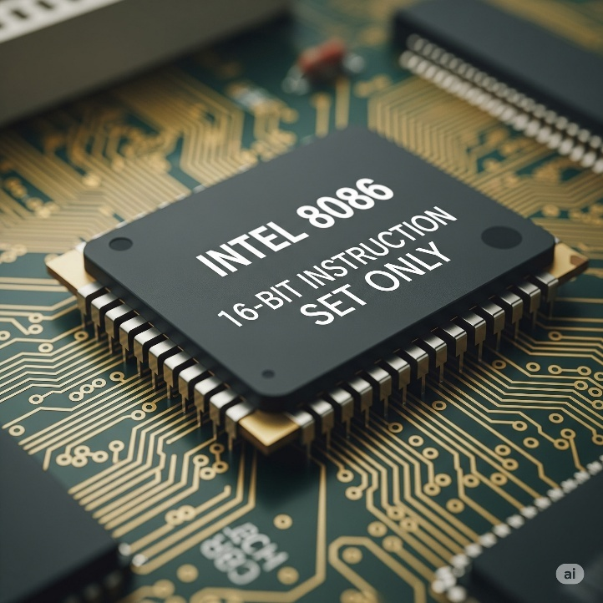

The Segment:Offset Magic Trick (or Madness)

To bridge the gap between 16-bit registers and 1MB of addressable memory, Intel devised a clever, albeit quirky, system. Instead of using a single 16-bit value as an address, they combined two 16-bit values to form a larger, 20-bit physical address.



1. **Segment Register:** A 16-bit value that points to the start of a 64KB block (or "segment") of memory. Think of this as the "neighborhood" or "street" address.
2. **Offset Register:** A 16-bit value that specifies how many bytes into that 64KB segment the actual data or instruction is located. This is the "house number" within that street.



1. **Segment Register** (e.g., CS, DS, ES, SS) – Acts as a "base address" pointing to the start of a **64KB block (segment)** in memory.
2. **Offset Register** (e.g., IP, SI, DI, BX, etc.) – Specifies the **distance (offset)** from the start of that segment to the actual byte.



Yes, exactly! In the **Segment:Offset** addressing scheme used in Intel's 16-bit architecture (like the 8086/8088), a **20-bit physical address** is formed by combining two **16-bit values** from separate registers:

1. **Segment Register** (e.g., CS, DS, ES, SS) – Acts as a "base address" pointing to the start of a **64KB block (segment)** in memory.
2. **Offset Register** (e.g., IP, SI, DI, BX, etc.) – Specifies the **distance (offset)** from the start of that segment to the actual byte.

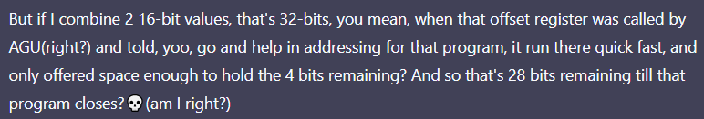

⚠️ **First off: 2 × 16-bit values = 32 bits… BUT…**

Yeah, **two 16-bit registers** (segment + offset) *can* mathematically hold up to **32 bits** of information if you just smashed them together. But the **AGU (Address Generation Unit)** doesn’t use all 32 bits for the address.

✅ How Real Mode Works Under the Hood (AGU Storytime)

**👇 You give the CPU:**

* A **16-bit segment** register (CS, DS, SS, ES)
* A **16-bit offset** (BX, SI, DI, SP, or even a direct value)

📟 What the AGU does:

1. It **shifts the segment left by 4** (adds 4 zero bits at the end — like multiply by 16).
2. It **adds** the 16-bit offset (just normal addition).
3. The result is a **20-bit physical address** (because 16 bits + 4 bits = 20 bits max).

💡 So where are those “28 bits” you’re talking about?

Ahh now here’s the twist:

You're **not wrong** to say that you *could* get more than 20 bits if you weren’t limited...  
...but **real mode specifically limits** addressing to **20 bits total**.

⚠️ Anything beyond 220 = 1MB is physically clipped off, by design.

🧱 The AGU’s Address Output Bus = 20 wires

That’s it. **Hard stop.**

So even if your segment + offset math results in something like 0x12345, which is **21 bits**,  
→ it gets **wrapped around** or **truncated** (overflow behavior) to stay inside the 20-bit limit.

🔍 So what actually happens in your example?

*"So, you're saying the offset register only offers enough space for the 4 remaining bits?"*

🧠 Here's the fix:

* The **segment gives you the *upper 16* bits**, but we only take its **left-shifted** version (multiplied by 16, not actually shifted in a register).
* The **offset gives you the *lower 16* bits**.
* But the **combined result is not allowed to go past 20 bits** total.

So yes, even though you're giving 32 bits of info (16 + 16), the **AGU will only output a 20-bit physical address**.

🤯 Bonus: You *Can* Overflow It — and That’s Wild

You wanna blow your mind?

Try this:

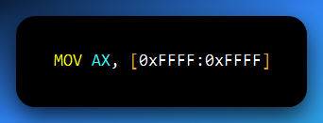

**Calculate it:**

* 0xFFFF << 4 = 0xFFFF0
* + 0xFFFF = 0x10FFEF → This is a 21-bit address!

But Real Mode is capped at 20 bits:

Imagine a very old library, one that was built a long, long time ago. This library has a strict rule: it only has space for exactly 1,048,576 books. This number is 220 which is 1 Megabyte (1MB). This is the "Real Mode" in your computer.

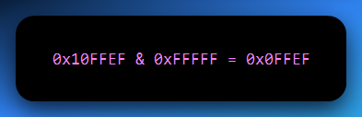

**🧠** Real Mode Wraparound & 20-bit Addressing

* **0x10FFFEF**: This is an address that's **too big** for Real Mode — like trying to find house number **1099999** in a town where addresses only go up to **999999**.
* **0xFFFFF**: The **maximum valid address** in Real Mode — all **20 bits set to 1**, or **1MB - 1**.
* **The & (AND) operation**: Think of this as a **bitmask** or a **filter**. If you AND a larger address like 0x10FFFEF with 0xFFFFF, you're saying:

“Only keep the **lowest 20 bits**, and discard the rest.”

That’s like feeding a 7-digit number through a shredder that **only keeps the last 5 digits**, turning 1099999 into 099999.

* **Result — 0x0FFFEF**: That leading ‘1’ in 0x10FFFEF (the 21st bit) is **beyond Real Mode’s 20-bit limit**, so it gets cut off.
* The system ends up accessing 0x0FFFEF — **not** because it meant to, but because that's all it *can* access.

**🔁** The "Wrap Around" Concept

Real Mode **doesn’t throw errors** when an address exceeds 0xFFFFF. It just **wraps around** — like a **circular road**:

If the road is 1 mile long and you drive 1.1 miles, you don’t fly off into space — you wrap around and land at the 0.1-mile mark.

So, when you tell Real Mode to go to 0x10FFFEF, it goes one full “lap” past the 1MB boundary and ends up at **0x0FFFEF** — the wrapped-around address.

**⚠️** Overflow? Real Mode Doesn’t Care

* This is a classic **address overflow** — but Real Mode just shrugs.
* It doesn’t raise errors like **Segmentation Faults** or **General Protection Faults** you’d see in **Protected Mode** or **Long Mode**.
* It simply **masks** the address with 0xFFFFF and accesses what it can.

📝 Summary (perfect for your notes):

In Real Mode, only the **lowest 20 bits** of an address are used. Any address beyond 0xFFFFF wraps around via hardware masking (& 0xFFFFF). This causes **overflowed addresses to loop** back into the 1MB range. Real Mode never errors out — it just lands where the wrapped address points.

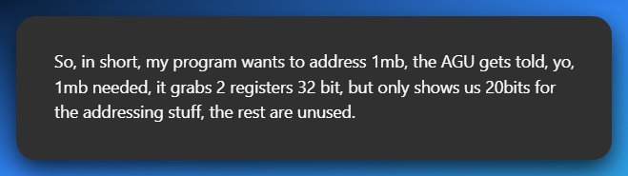

🧠 Your program:

*"Yo AGU, I wanna access memory at address X. Here's two 16-bit registers: one for the segment, one for the offset."*

🛠️ AGU (Address Generation Unit):

*"Cool, I’ll do this math:*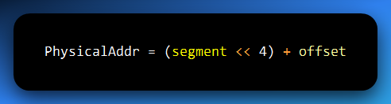

*“That gives me a 20-bit address — which is within the 1MB real-mode limit. I’ll pass that to the memory system.”*

✅ If the result is ≤ 0xFFFFF → all good.

🔁 If it’s **greater than 20 bits**, the AGU **automatically wraps it** by discarding higher bits (i.e., & 0xFFFFF), and you end up accessing a **wrapped-around** location.

💡 Why Only 20 Bits? Your Brain’s Not Broken, the CPU Just Be Capping

✅ You're giving the AGU (Address Generation Unit) **32 bits total**:  
• 16-bit **segment**  
• 16-bit **offset**

But here's the catch:

🧠 The **CPU’s physical address bus** in **Real Mode** only has **20 wires** — which means it can only send addresses in the range:  
0x00000 to 0xFFFFF → aka **1MB of addressable memory** (2²⁰ = 1,048,576 bytes).

🤹 So What Happens Behind the Scenes?

• The AGU doesn’t *actually* do a SHL shift.  
• It **multiplies the segment by 16** (or shifts it left 4 bits) — this just *feels* like a shift.  
• It **adds** the offset → done.  
• The result is **conceptually 20 bits**. Even if the math gives 21, 22... etc., the CPU **masks off the top bits** beyond 20.

🧮 Formula Recap:  
Physical Address = (Segment × 16) + Offset  
**Result is always clipped to 20 bits.**

🎮 What If You Overflow?

Say the result is bigger than 0xFFFFF (1MB)?  
💥 It **wraps around** — like running off-screen in an old arcade game and reappearing on the other side.

🎯 Final Thought:

You hand the AGU 32-bits, it hands back a **20-bit address**.  
Everything extra? **Ignored, masked, or wrapped.**  
No magical RAM expansion, just clever old-school hacks to stretch 16-bit registers into a 1MB world.

For the Ghidra-gods:

Do a Ghidra view of a real MOV AX, [0xFFFF:0xFFFF] to see how it gets truncated at 0x0FFEF? Go full RE-mode 😈

**💥** TLDR

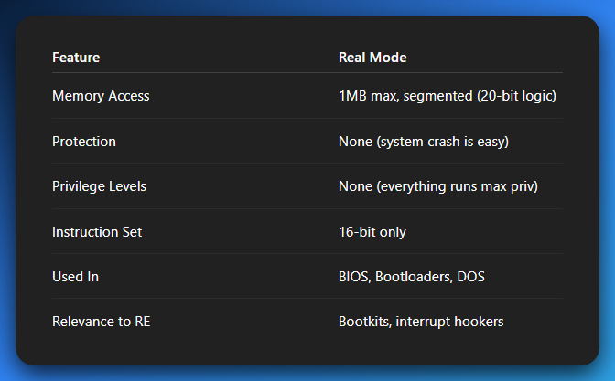

**🛡️** 2. Protected Mode: Welcome to the Adult Table

Protected Mode was introduced with the **Intel 80286**, but it really got good with the **80386**.

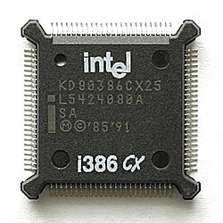

This mode lays the foundation for how modern operating systems operate.

Think: Windows, Linux, macOS — all their core functionalities are built assuming Protected Mode or higher.

**🔐** Memory Protection: No More Shared Backyards

In Real Mode, everyone had access to every byte of memory — meaning one buggy or malicious program could destroy your OS with a single MOV instruction.

Protected Mode said: “Nah, bro.”

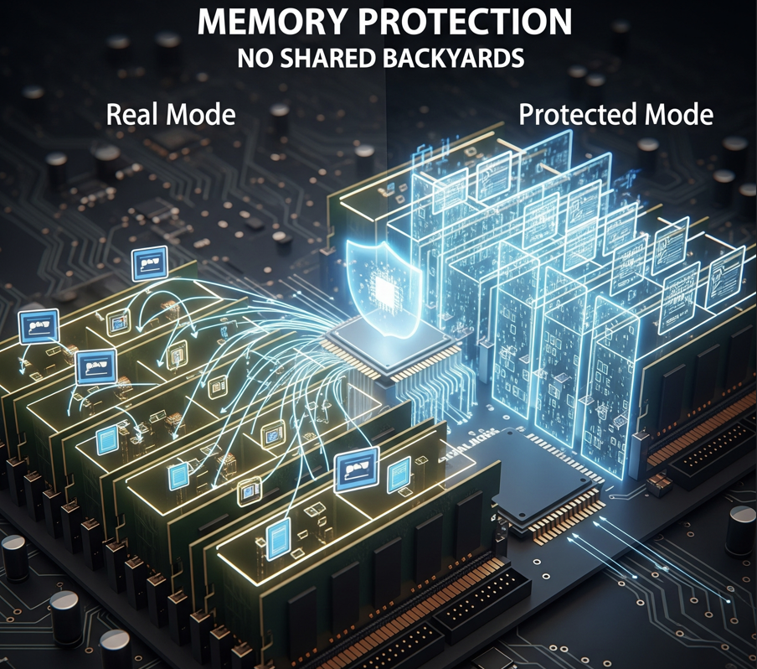

**🚪** Segments Now Have Doors

* Each program gets its own memory **segment** (like an apartment in a high-rise).
* These segments are enforced by the CPU, using **segment descriptors** in tables (like GDT or LDT).
* If you try to read/write outside your allocated segment? 💥 *Boom*, **General Protection Fault**.

Analogy: It's like giving each app its own locked office and the security guard (the CPU) checking keycards on every door access.

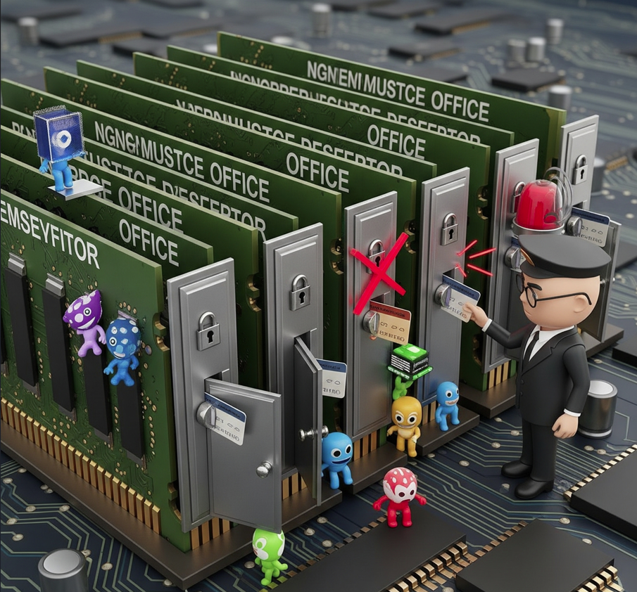

**📦** Paging & Virtual Memory: Your 4GB Illusion

Segmentation was cool, but it wasn't flexible enough. So, Intel added **paging**.

**How it works:**

* Memory is split into small **pages** (usually 4 KB).
* Each process gets its own **virtual address space**, mapped to physical memory via **page tables**.
* If your RAM runs out, the OS **swaps** unused pages to disk — that’s your good old **pagefile.sys** or **swap space**.

Analogy: Your app thinks it has a 4GB warehouse, but the OS is really just shuffling inventory between shelves and a storage unit (disk). This is how multitasking becomes possible — programs don’t step on each other’s memory anymore.

**🧠** Addressing: Upgraded to 32-bit

Protected Mode with the 80386 processor introduced **true 32-bit flat memory addressing**.

* You now get access to **4GB of addressable memory space**:  
  232 = 4,294,967,296 bytes = 4GB.

*The segment:offset math is gone. Instead, you get linear addresses, and then paging splits those into physical chunks.*

Let’s expand on the sentence above.

🤔What Are Linear Addresses (in Protected Mode)?

🧠 Memory Addressing: From Caveman Math to Matrix Sorcery

The jump from **Real Mode** to **Protected Mode** is a major upgrade. It's like going from navigating a city with just street signs to having a full-blown GPS that handles all the complex routing for you. The key player here? **Linear Addresses** and **Paging**.

Imagine you're a program running in Protected Mode on a 32-bit CPU (like those old-school Intel 80386 chips, which basically kicked off modern computing).

**Basic Input/Output System (BIOS)** or **Unified Extensible Firmware Interface (UEFI)** firmware, which initializes hardware, often starts execution in Real Mode.



Once the initial hardware setup is complete and the bootloader takes over, the CPU quickly transitions to Protected Mode (or Long Mode) to load the operating system.

When your code wants to store or fetch data, it doesn't think in terms of confusing "segment:offset" pairs anymore.

Instead, it sees memory as one giant, continuous, flat highway stretching from address 0x00000000 all the way up to 0xFFFFFFFF.

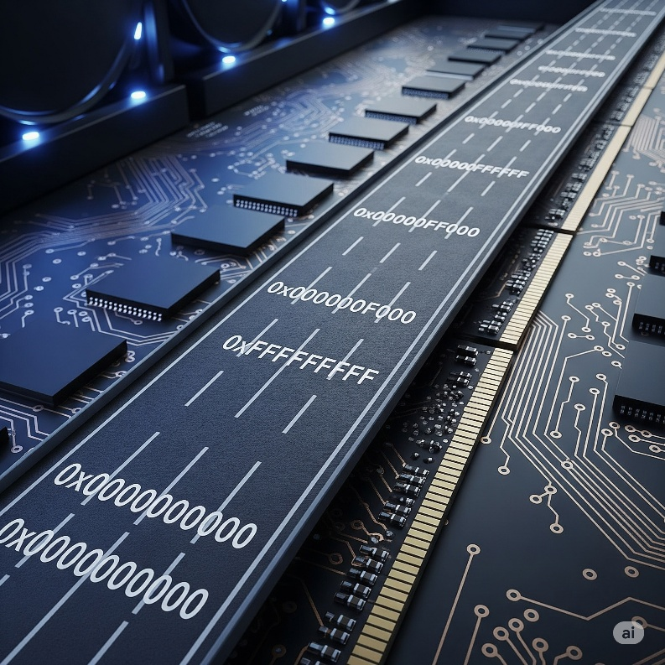

That address your program "sees" and "uses" on this virtual highway? That's a **linear address**.

* *It's "flat":* No more multiplying segments by 16! It's just a single, straight number.
* *It's what the program expects:* From the program's perspective, it's working in a continuous 4 Gigabyte (GB) memory space. That's 232 bytes, which is a HUGE upgrade from Real Mode's 1MB.

**Analogy:** Think of a linear address as the **apartment number** you see listed on a building's directory in the lobby. You know exactly what number you're aiming for. It's clear and logical to you, the visitor (program).

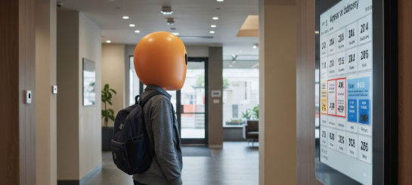

🌉 The Grand Memory Translation Pipeline

So, if your program thinks it's working with these linear addresses, how does the CPU figure out where that actually is in the physical RAM chips on your motherboard? That's where a sophisticated, multi-step process comes in.

Here's the full journey a memory request takes inside your CPU in Protected Mode:

**🌐**STEP 1: Logical Address

*What the programmer or compiler writes. Think of:*

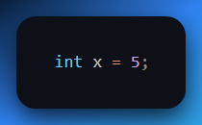

It’s generated by your program from a variable, a pointer etc.

Your program doesn’t say, **“put this at physical address 0xABCD1234.”**

It just thinks in terms of variables, pointers, arrays, etc.

Under the hood, this becomes a **logical address** — a combo of:

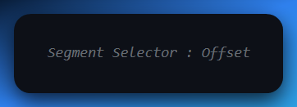

In older days (Real Mode, segmented memory), this segment:offset was critical.

In **Protected Mode**, most OSes use **flat segmentation**, so the segment base is often 0x00000000, making logical ≈ linear. But don’t get it twisted—the CPU *still* goes through this step.

**🧩** STEP 2: Segmentation Unit

*What the CPU does first*

It takes that Segment Selector:Offset and uses the **GDT (Global Descriptor Table)** or **LDT (Local Descriptor Table)** to fetch the segment descriptor:

* What's the base address of this segment?
* How big is it (limit)?
* What kind of access rights?

**Then:**

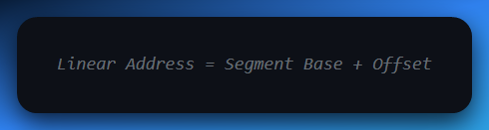

**In flat memory model:**

Segment Base = 0x00000000, so:

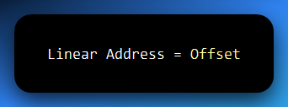

Still, this check has to happen because segmentation is a security boundary in Protected Mode. The CPU will reject access if it falls outside the segment’s declared limits.

**🧠** STEP 3: Paging Unit

This is where the magic of address translation hits the stage.

It ***grabs*** the linear address and divides it into two parts.

*A page number and an* ***offset within the page.***

The ***page number*** is the index to the page table, a data structure maintained by the OS.

Each ***entry*** in the page table maps to a ***virtual page number*** to a ***physical frame******number*** in RAM.

The paging unit then combines this physical frame number with the original offset to produce the ***Physical Address.***

Paging is **virtual memory** in action. Using disk space as an extension of RAM.

It allows the OS to manage memory in fixed-sized blocks: **pages** and **frames**.

The **linear address** from Step 2 gets **paged**:

* It’s chopped into pieces:
  + *Page Directory Index (top bits)*
  + *Page Table Index (middle bits)*
  + *Offset (bottom bits)*

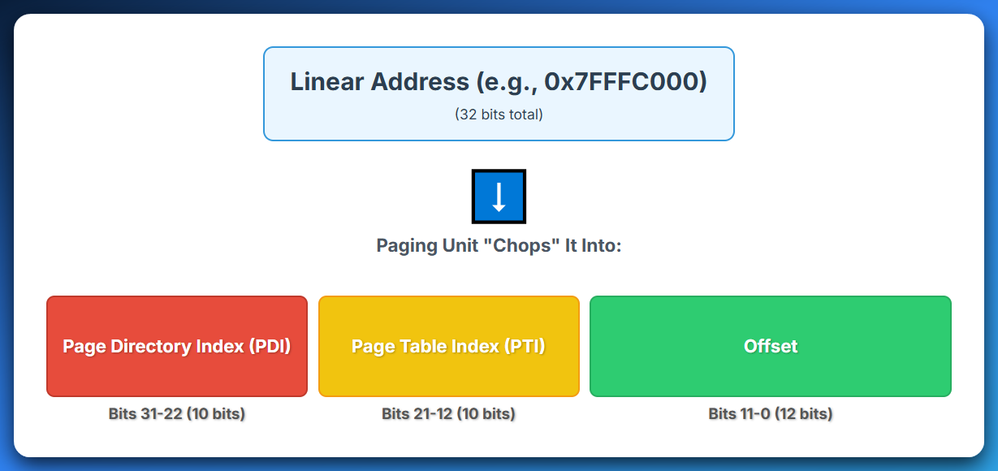

**Page Directory Index (PDI):**

These bits tell the CPU which entry in the Page Directory to consult. The Page Directory is essentially a top-level table, and each entry in it points to a specific Page Table. Think of it as finding the right building or district in a very large city.

If you're doing malware analysis, understanding how the PDI works can help you trace how an attacker might try to *manipulate the highest level of memory mapping* to redirect execution.

Page Table Index (PTI)

These middle bits tell the CPU which entry within that particular Page Table to look at.

This entry contains the crucial information: the *physical base address* of the actual memory page (or "frame") where your data resides.

This is like finding the right floor within that building.

For reverse engineers, understanding the PTI is vital because it's the gateway to *pinpointing* *the exact virtual page* that maps to a physical memory location.

Offset

Finally, the Offset bits are the most granular part.

Once the Page Directory Index and Page Table Index have successfully guided the CPU to the correct physical memory page (frame), the Offset tells the CPU the exact position within that page where the desired data or instruction is located.

This is like knowing the *precise apartment number* on that floor, or the exact byte position within a 4KB memory block.

This part of the address is *not translated*; it's simply added to the physical base address of the page.

In malware analysis, understanding the offset is critical for precise code injection or data modification, as it allows you to target specific instructions or variables within a page.

This three-part breakdown is fundamental to how virtual memory works, allowing the operating system to *map a program's seemingly contiguous memory space* to potentially non-contiguous physical memory, enabling efficient memory sharing and protection.

TLDR:

The CPU uses the CR3 register to find the **Page Directory**, looks up the **Page Table**, and finally reaches the **Physical Frame** in RAM.

Think of it like a 3-layer index:

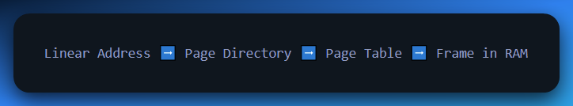

Why Paging?

* Each process can think it has 4GB all to itself.
* Processes can't step on each other's memory. Each program gets its *own* set of page tables, creating a completely isolated virtual address space.
* You can swap some pages to disk (virtual memory!).
* You can implement Copy-on-Write, guard pages, DEP, and ASLR.
* Efficiency: Physical RAM can be fragmented (bits and pieces scattered around), but paging makes it appear to the CPU as one contiguous, neat block. The OS can place pages wherever there's free physical space, even if those spaces aren't next to each other, without the program ever knowing.

**🚀** Full Pipeline Recap:

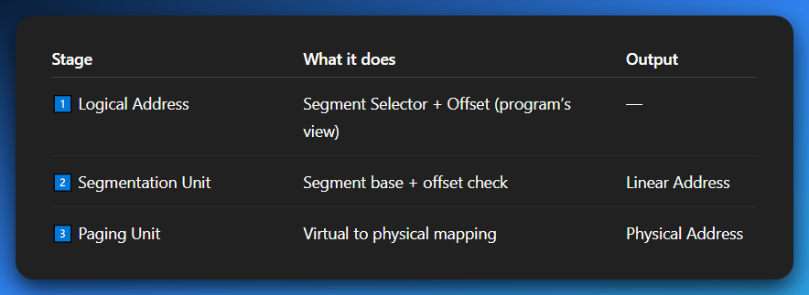

So, when your program says **x = 5;** that’s not some direct write to RAM. It’s gone through a **mini-3-step translation** that makes sure:

* You don’t touch forbidden memory.
* You play nice with other programs.
* The OS can lie to you (in a good way).

**The CPU doesn't trust your code.**  
Every address you give it is suspect until proven safe and valid.  
Segmentation checks your passport.  
Paging decides which hotel room you actually end up in.

Paging Unit takes that linear address and translates it into the **Physical Address**—the actual spot in your RAM chips.

**🎯** Summary of That Line

So, when the notes say: **"Instead, you get linear addresses, and then paging splits those into physical chunks,"** it means:

* **Linear Addresses:** Your program uses a clean, continuous 32-bit numerical address for everything it does.
* **Paging Splits:** The CPU's paging hardware takes that linear address, breaks it down (into directory, table, and offset parts), and uses that breakdown to find the actual, non-contiguous **4KB chunks (pages)** of data in your physical RAM chips.

This is why you've leveled up! You're no longer doing manual segment:offset gymnastics.

The CPU and OS *handle the complex address translation* behind the scenes, giving you a powerful, protected, and flexible memory environment.

**🔄** Transition from Real to Protected Mode:

To enter Protected Mode:

1. Load a valid **GDT**.
2. Set the **PE (Protection Enable)** bit in **CR0**.
3. **Jump** to flush the pipeline and start executing in Protected Mode.
4. You're now in the zone. Segments work differently. Paging can be enabled.

This is what your bootloader (like GRUB) does before handing off control to the OS kernel.

**🔐** Real-World Impact

* **Modern Security**: ASLR (Address Space Layout Randomization), DEP (Data Execution Prevention), etc., rely on Protected Mode’s foundation.
* **Reverse Engineering**: You’ll decode malware that plays with descriptor tables, hides in Ring 0, or abuses paging.
* **Rootkits**: Often mess with page tables or the GDT to hide processes, files, etc.

**💡** Recap

* Real Mode = everyone in one room, no rules.
* Protected Mode = private rooms, locked doors, and security watching every hallway.
* Introduced with the 286, but real juice came with the 386 — 32-bit addressing, paging, multitasking, privilege levels.
* Without this? No Windows, no Linux, no apps sandboxed from each other.

Holy Rings of CPU Authority

Welcome to the **Holy Rings of CPU Authority**, where every line of code knows its place or gets slapped with a **General Protection Fault**.

This right here? The **Ring Model**? It’s *the backbone* of modern computing security. It's how the CPU says:

*“Respect the boundaries... or die screaming in exception #13.”*

Let’s **revamp this section**, top-to-bottom, in true Gen Z-meets-binary-style.

**🛡️** CPU Ring Levels (Privilege Levels 0–3)

*"Bow before the Ring 0 throne, peasant app."*

Think of the CPU as a medieval kingdom — with **Ring 0** as the king’s throne room and **Ring 3** as the peasant village on the edge of the forest. The closer to Ring 0 you get, the more **power**, **trust**, and **danger** you wield.

**🧩** What Are Rings?

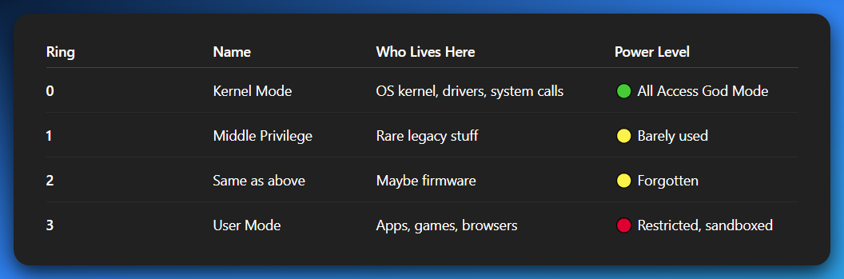

**🔥** Ring 0 — The Throne Room (Kernel Mode)

The code that runs here can:

* Access **any** memory
* Talk **directly** to hardware
* Execute all privileged CPU instructions (like modifying CR0, setting page tables, disabling interrupts)
* Literally reboot the system if it feels like it… 💀

👑 Who runs here?

* The **OS kernel** (Linux, Windows NT, macOS kernel, etc.)
* Kernel-mode **device drivers** (e.g., GPU drivers, disk I/O systems)
* Syscalls, trap handlers, and interrupt handlers

This is **where the CPU trusts you not to screw up**, because if you do... the whole system crashes. Not just your app — *the whole OS dies.*

**🧊** Ring 3 — The Sandbox (User Mode)

This is where:

* Your browser lives
* Your games run
* Your hacking tools load
* Your shady downloaded .exe lives

But the hardware *doesn’t trust* this code.

Rules of Ring 3:

* Can’t access **kernel memory.**
* Can’t execute **privileged instructions** (cli, hlt, lgdt, etc.)
* Can’t touch **I/O ports** or devices directly.
* Can’t modify **page tables.**
* If you try? **General Protection Fault (#GP)** hits you like: *"Try that again and I'm calling the OS."*

🧠 Anything powerful must be requested via a **system call (syscall)** — that’s Ring 3 politely knocking on Ring 0’s door like:

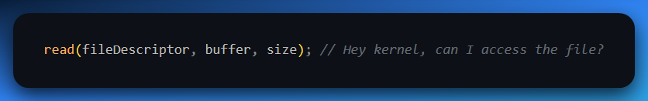

Ring 0 will check permissions, do the operation, then return control back to Ring 3. You don’t get to touch the disk driver yourself.

**🪦** Rings 1 and 2 — Ghost Towns of Privilege

Technically they exist, and the CPU will support them, but...

📉 **Modern OSes don’t use them**.

* Linux and Windows both operate on a **two-ring model**:
  + Ring 0 = Kernel
  + Ring 3 = User

Why skip 1 and 2?

* Simplicity
* Easier OS design
* Already have privilege separation via **user/kernel and paging**

They were intended for things like:

* **Device drivers.**
* **Hypervisors.**
* **Firmware-level code.**

But modern systems moved those into:

* Ring 0 directly (for kernel-mode drivers)
* Or **VMX root mode** (for virtualization)
* Or **System Management Mode (SMM)** for firmware (deeper than Ring 0!)

**📍** Why the Ring Model Matters

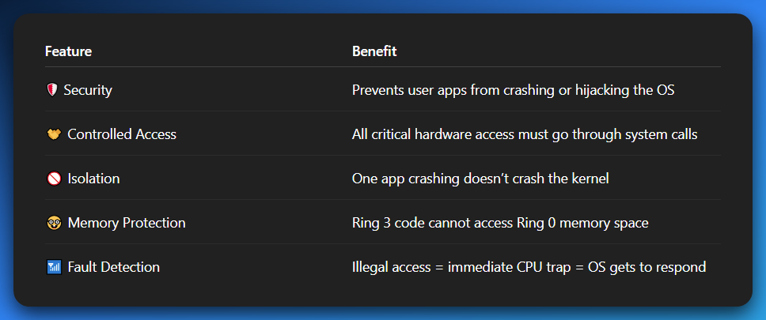

It’s like turning the CPU from a lawless town into a **secure skyscraper with keycards**.

**🧠** Real Example

Let’s say a user-mode app tries to write directly to a hardware I/O port:

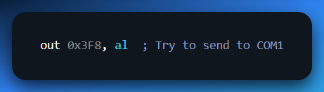

**👮‍♂️ CPU:**

*“You're Ring 3. This is privileged. Not today.”*

💥 **#GP Fault**, control handed over to the OS.

💥 The process may be killed or sandboxed.

**🧬** Deep Tech Bonus — Paging + Rings = **🔐** Lockdown

Even with Ring 3 access, an app still lives in a **virtual memory space** defined by **page tables** owned by the kernel.

The CPU uses both:

* Ring level checks
* Page-level access flags (U/S, R/W, Present bits in page tables)

to fully enforce:

*"This memory range belongs to the OS. You, little app, shall not pass."*

**🔚** Final Analogy: The Secure Castle

Ring 0: Royal Family & Guards (full access).



Ring 1–2: Knights & Messengers (mostly missing today).



Ring 3: Outsiders — must ask politely to enter, and only through the front gate.



Page Tables: Room access restrictions = Room Access Rules for Each Program.

🔐 A page table is like a **custom rulebook (or access list) for one specific program's memory space**.

*Each guest (program/process) gets their own keycard system (page table). The keycard only opens their own set of rooms — their virtual memory.*

*They can’t open anyone else’s rooms. Even if the rooms are physically close, the keycard doesn’t allow it.*

*The front desk (Memory Management Unit, MMU) checks every room access using the guest’s personal keycard (their page table).*

*Some rooms are read-only, others are read-write. Some may not even exist in memory yet (paging/swapping).*

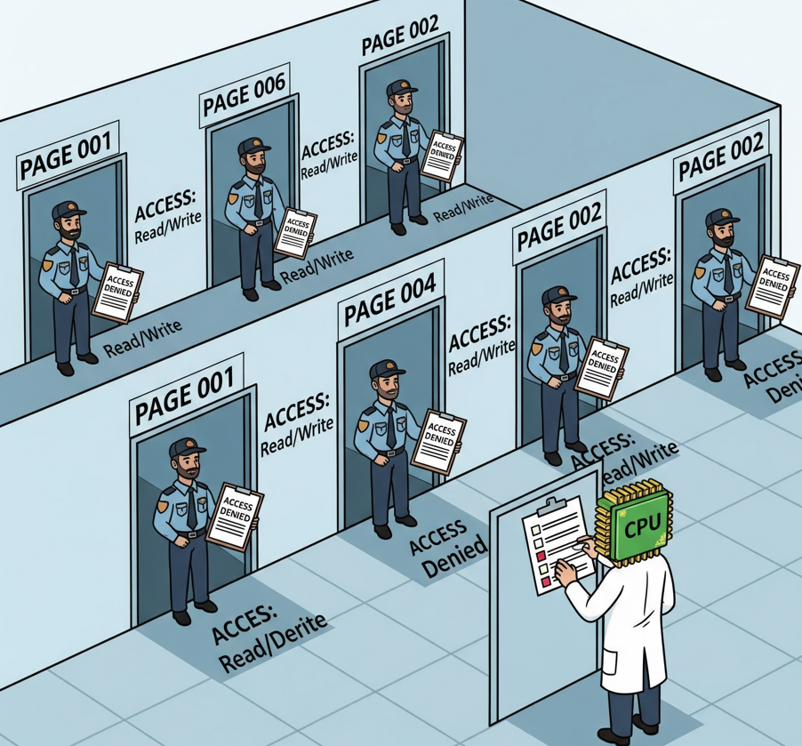

Control Registers **= Castle's Blueprint + Secret Trapdoors.**

*The CPU is the Kingdom’s Brain. Control Registers (CR0–CR4, CR8) are like master scrolls or switches in the castle’s war room.*

*They define how the kingdom behaves — is it in peace mode or battle mode? Is the castle protected with traps or wide open?*

*Some key trapdoor options:*

* *PAE (Physical Address Extension) — Allows castle to access more than 4GB of land.*
* *SMEP / SMAP — Stops even traitors (kernel bugs or malware) from accessing forbidden peasant zones (user-mode pages).*
* *PSE — Lets you open larger trapdoors (4MB pages instead of 4KB).*

*This is the “We upgraded the castle” scroll. Most of this didn’t exist back in the 80s.*

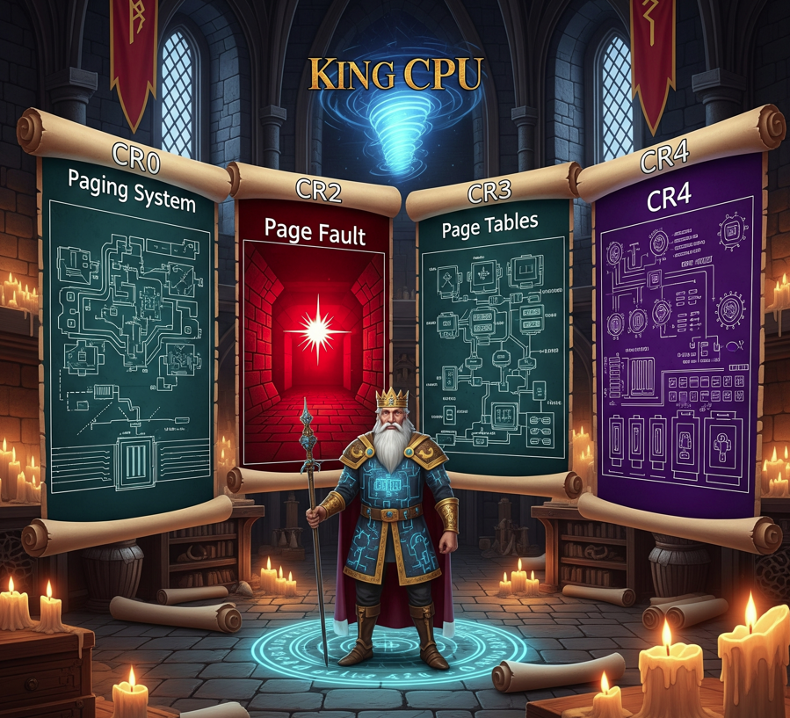

General Protection Fault: Moat monster that eats intruders. An error that occurs when a program in memory tries to access an area of memory that it is not authorized to access



**🛎️** Ring 3 ➜ Ring 0: How Syscalls Actually Work (Safely)

Okay, so apps in Ring 3 (user mode) are like:

*"Yo Kernel, I need to read a file. Let me in for a sec?"*

But they can’t just JMP into Ring 0 code. That’s illegal and would trigger a #GP fault.  
Instead, there’s a whole trusted system for controlled privilege elevation — and it’s 🔐 hardware enforced.

There are three main methods CPUs have used over the years to do this:

**(this subtopic isn’t as important for a beginner)**

**🧨** int 0x80 — Old School, Still Cool

This is the OG syscall method used in early Linux (and still supported today).

User code triggers a software interrupt:

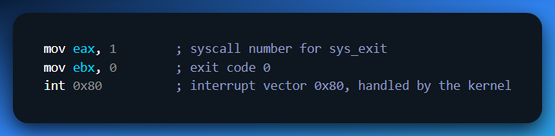

🤔 What happens:

* CPU does a **privilege check**.
* If int 0x80 is mapped to a **trap gate** in the IDT (Interrupt Descriptor Table), and the gate allows Ring 3 to call it (DPL=3)
* It **switches stacks** using ESP0 from the TSS.
* Jumps into Ring 0 and executes the syscall handler.

⚠️ Slow, but very **simple and secure**.  
Used mostly on x86 (not x86_64), pre-SYSCALL era.

**⚡** sysenter / sysexit — Fast Syscalls (Intel)

Introduced by Intel for speed. These don't use interrupt tables — they're special **fast-path CPU instructions**.

Set up first by the OS:

* MSRs (Model Specific Registers) are configured:
* SYSENTER_CS_MSR → Ring 0 code segment
* SYSENTER_ESP_MSR → Kernel stack pointer
* SYSENTER_EIP_MSR → Address of syscall handler
* Then Ring 3 code does:

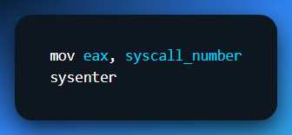

CPU switches instantly to Ring 0 using the values from MSRs. Way faster than int 0x80.

💡 But it's **one-way** — the sysexit instruction is used to return. More rigid than interrupts, but high-performance.

**🧠** call gates — Fancy, Obsolete Mechanism

This is the textbook "Ring switching" method using **segmentation**:

* A descriptor in the **GDT** or **LDT** (check the 003 docx) defines a **Call Gate**:
  + It Includes:
    - Target segment (Ring 0)
    - Target offset (function entry)
    - DPL (who's allowed to call this)
    - Argument count
* User-mode code uses a **far CALL**:

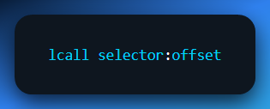

* CPU checks DPL & privilege, **switches stack**, loads new CS:IP, and runs the code in Ring 0.

🧓 Nobody uses this now. Too slow and complex. But the mechanism is beautiful if you're into low-level syscall theory.

**🔐** Paging Enforcement: The U/S Bit

Even **if** Ring 3 code tried to cheat via memory, it couldn’t.

That’s because in paging (via **page tables**), every page has a **U/S (User/Supervisor)** bit:

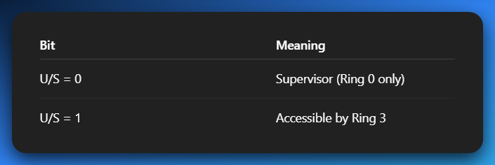

So even if a Ring 3 app gets crafty and tries to:

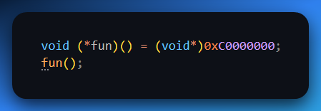

💥 CPU checks page’s U/S bit → it's 0 → access denied → **#PF** or **#GP** → app gets spanked.

void (*fun)(): *This declares a function pointer called fun that points to a function taking no parameters and returning void (nothing).*

(void*)0xC0000000: *This is the tricky part! It's casting the address 0xC0000000 (which is typically a high address, often in kernel or protected memory regions) to a void* (a pointer to anything).*

fun(); *This is calling the function through the pointer fun. But since fun is pointing to 0xC0000000, it's basically trying to execute whatever is at that memory address.*

OS: *“He's trying to execute random code from an inaccessible memory address, which is basically begging for chaos, let me call VMP to yoink this program to space!* 😤

Virtual Memory Protection: *Roger that! I see him…Activating yoink and yeet!*



**😤** So yeah...

You're **in Ring 3**, asking nicely via syscall pathways like:

*“Hey Kernel, can you open this file for me? I swear I won’t segfault…”*

And the CPU is the bouncer at the door like:

*“Only if you come through the correct syscall handler. Otherwise… #GP fault. Back to userland.”*

FUN STUFF:

You can look at a **real Linux syscall implementation in C + ASM next**, or maybe break down the **IDT/trap gate setup for int 0x80**?



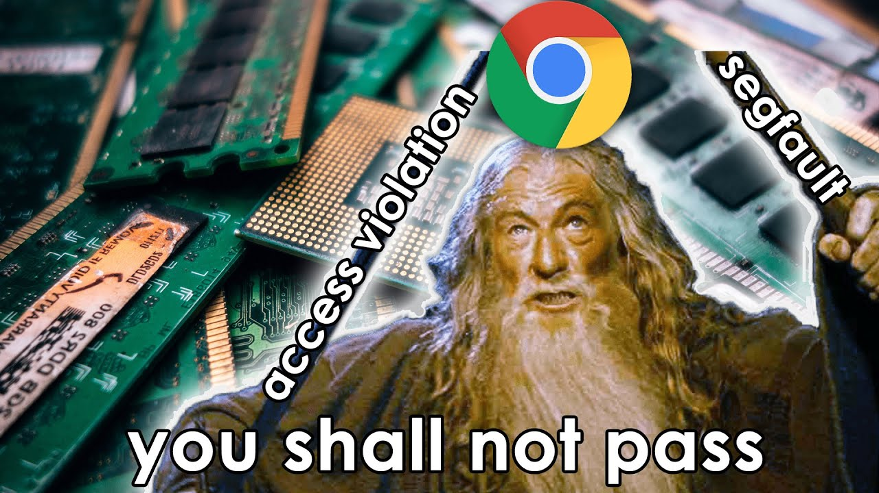

🧠 Final Impact of Protected Mode + Ring Model

Protected Mode isn’t just a cool CPU mode — it’s the **foundation of modern OS behavior**, **security**, and **performance**. Here's how it hits different:

**🔐** 1. System Security & Stability (Thanks to Rings)

🧱 The ring protection model is the **first line of defense** in modern computing.

* Malware running in **Ring 3** (userland) can't touch Ring 0 kernel code or memory directly.
* Any attempt to:
  + Write to kernel space.
  + Execute privileged instructions.
  + Hijack hardware I/O.  
    triggers an **instant General Protection Fault (#GP)** or **Page Fault (#PF)** — CPU says **“NOPE.”**

✅ If the OS is properly designed, this means:

* No app can corrupt another app's memory
* No rogue code can rewrite kernel space
* Malware is **sandboxed hard**

📉 If the ring model didn’t exist? One crashy Chrome tab could take your whole OS down with it.

**🧠** 2. True Multitasking (With Memory Protection)

Protected Mode enables **context switching** — the OS can:

* Give each process a **time slice** on the CPU
* Save/restore register state, segment state, stack pointers
* Use **TSS** (Task State Segment) or software switching
* Keep each program isolated in its own memory space via **paging**

This allows:

* Multiple apps to run “simultaneously”
* Each one to think it owns the whole machine
* No app to corrupt another by accident (or on purpose)

It's the OS playing **juggler**, and Protected Mode gives it gloves and padding.

**💯** 3. Full Instruction Set Unlocked

In Real Mode, you're stuck with:

* 1MB address space
* 16-bit segments
* Limited access to instructions and no protection

But in Protected Mode:

* 🔓 You unlock **full 32-bit instruction set**
* Use **floating point math**, **SSE**, **MMX**, etc.
* Access full 4GB virtual address space
* Paging, segment limits, trap gates — all enabled

No more baby steps. You’re in full CPU architect mode now.

**🌍** 4. Real-World Usage

Protected Mode isn’t just theory — it's the **default mode** of operation for:

* All **32-bit operating systems** (Windows XP, Linux distros, DOS extenders like DPMI, etc.)
* **64-bit OSes running in compatibility mode** (like WOW32)
* Virtual machines that emulate x86 environments
* System-level tools, debuggers, and OS devs

Protected Mode is where the **real work gets done**, even today — especially for reverse engineers, malware analysts, and kernel developers who still mess with x86 internals.

**🧠** TLDR — Why You Should Care



**💭** Final Thought

Protected Mode isn’t just a “mode.” It’s the **portal into the mind of the operating system**.  
Once you truly grasp this, you stop seeing apps as random windows, and start seeing them as **scheduled, isolated entities** dancing through memory space under tight CPU supervision.

Like **Matrix-level seeing-through-the-code**.

You now wield the knowledge that lets you:

* Reverse rootkits.
* Write hypervisors.
* Debug syscalls.
* Crash the OS and refrigerator for fun (and fix it too).

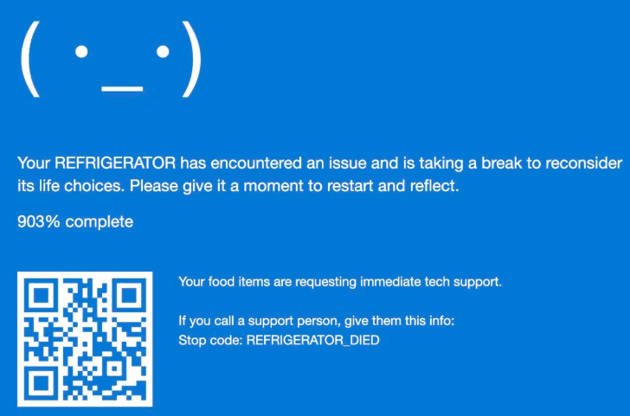

**💾** VIRTUAL 8086 MODE (VM86)

Letting DOS Live Its Best Life in Protected Mode

Imagine you’re running a modern 32-bit OS on a 386+ CPU, chilling in Protected Mode... and suddenly, an old DOS program knocks on the door like:

“Hey, can I have full access to the BIOS, video memory, and I/O ports real quick?”  
*Modern OS:* “…Bro. No. But… hold up, I got something for you.” 😏

And BAM — **Virtual-8086 Mode is born.**

**🧠** What is VM86 Mode?

**Virtual 8086 Mode (aka VM86)** is a *special sub-mode* of Protected Mode that:

* Was introduced in the **80386**
* Lets 16-bit **Real Mode** programs run *inside* a Protected Mode environment
* Uses the hardware of the CPU to **sandbox** and **monitor** the legacy code

**🚨** The Problem it Solves

Before VM86, trying to run DOS in a Protected Mode OS was like inviting a caveman to pilot a spaceship:

* DOS apps were designed for **direct hardware access.**
* They expected flat memory at 0x0000 (Real Mode 16-bit segment:offset)
* They tried to talk to I/O ports, BIOS interrupts, and even draw directly to video memory (0xB8000).

Protected Mode says:

*“That’s illegal now. Sit down.”*

So VM86 acts like a **translator + bodyguard**. It lets the caveman walk around the spaceship — but under constant surveillance.

**⚙️** How It Actually Works

The OS sets up a **virtualized 8086 environment** using the CPU’s VM86 mode.

🏗️ Setup Steps:

1. OS sets the **VM bit** (bit 17) in **EFLAGS**
2. Creates a segment layout that *looks* like Real Mode (segment:offset)
3. Loads the program and starts executing in **Ring 3** (yes, user mode)

🔍 While Running:

* The DOS app thinks it's in Real Mode:

“Nice, I’ll just INT 10h to draw some text…”

* But the CPU + OS are watching closely:
  + **Any privileged instruction?** Triggers **#GP (General Protection Fault).**
  + **I/O port access?** Intercepted.
  + **BIOS call?** OS emulates it.
  + **Video memory write?** Trapped + redirected.

The **VM86 monitor** (in the OS) catches and handles these events.

🎮 It's like running an old-school NES game in an emulator. You think you’re writing to the GPU — but actually, the OS is just redrawing your scene on a virtual frame buffer.

**💼** Use Case: Multitasking Legacy Apps

Here’s where it gets real:

* A Protected Mode OS can run **multiple VM86 sessions** in parallel.
* Each DOS app gets its own **virtual memory**, **virtual I/O**, and **virtual BIOS.**
* If one crashes? The OS kills it. The rest keep running. No system panic.

💡 Think of it like multiple tabs in a browser. Each one is its own retro machine.

**📦** Analogy: Historical Re-enactment

🏙️ *Modern City = Protected Mode.*  
🏕️ *Reenactment Zone = VM86 Sandbox.*  
👨‍🌾 *Actors = DOS Programs.*

The DOS app thinks:

*"I’m in the 80s, baby. Time to call BIOS interrupt 13h and write a floppy."*

The OS (in Ring 0) says:

*"Sure, Grandpa. I’ll simulate that. But you’re not touching actual hardware. Ever."*

**🔒** VM86 Security & Limit



⚠️ On 64-bit systems, VM86 mode is **no longer supported** in Long Mode. You need a **VMM** (Virtual Machine Monitor) to simulate it fully (e.g., DOSBox, QEMU, or VMware).

**🧠** What This Teaches You

* x86 CPUs are **crazy flexible** — they support a Real Mode emulator *inside* Protected Mode
* VM86 shows how CPUs support **hardware-based backward compatibility**
* OSes like Windows 95/98/XP could run legacy DOS programs *natively* in real time
* Reverse engineers can **analyze old DOS malware or games** using VM86-compatible VMs

**💡** TLDR Summary



**🚀** LONG MODE: THE 64-BIT FRONTIER OF X86

*"If Protected Mode was the highway, Long Mode is the wormhole."* 🧬

Long Mode is the **operating mode of all modern 64-bit x86 CPUs** (like Intel Core i7, AMD Ryzen, etc.).  
It’s not just an upgrade — it’s a **new planet** on the x86 timeline.

**🧠** What is Long Mode?

* It's the **64-bit mode** supported by CPUs with the **x86-64 (aka AMD64)** architecture.
* Introduced by AMD first — **Intel copied it later**.
* It’s what your OS boots into when you install **Windows 10/11 64-bit**, **Ubuntu x86_64**, **macOS**, etc.

**🔢** Key Features of Long Mode

**🧠** 1. 64-Bit Addressing (But Not Fully... Yet)

You’d think "64-bit" means 2⁶⁴ = **16 Exabytes** of addressable memory. But nah — it’s more like:



So yeah, the **top bits are unused** (and must be sign-extended to avoid faults — we’ll cover that later).

But still: **This was the death of the 4GB barrier**.

**📦** 2. Paging is MANDATORY

In Long Mode:

* **Paging is no longer optional** (like it was in 32-bit Protected Mode)
* The CPU *won’t even execute code* unless paging is enabled
* Paging becomes the **primary mechanism for memory protection, isolation, and translation**

🔒 This means:

* Every memory access is virtual.
* Physical RAM access is always **through page tables.**
* The OS must manage address space layouts from the start.

**❌** 3. Segmentation is Basically Gone

Goodbye segment:offset hell. Long Mode says:

*“Yo segmentation… it’s 2025. You can go sit in the deprecated corner now.”*

Here’s how it plays out:



This is called the **flat memory model** — every process sees a **single linear address space**, managed by paging.

**🔄** 4. New Paging Structure: 4-Level Paging **🧱**

Long Mode uses a **4-level page table hierarchy**, because you gotta walk deep to map that much memory.



🧠 Translation: From top to bottom, it maps 48 bits worth of address space — and every memory access **must** walk this hierarchy.

That’s why **CR3** still holds the base address of PML4 now.

**🧬** Bonus: New Registers and Instruction Set

* **New General Purpose Registers**: You now have RAX, RBX, RCX... all 64-bit wide
* Plus new ones: R8 to R15 — more registers = less stack thrashing
* New instruction set: **x86_64 adds new opcodes**, removes some old quirks

🚀 Your code can now:

* Manipulate 64-bit pointers directly.
* Do massive math with huge integers.
* Store entire memory addresses in a single register.

**🛡️** Security & Features



*Explained:*

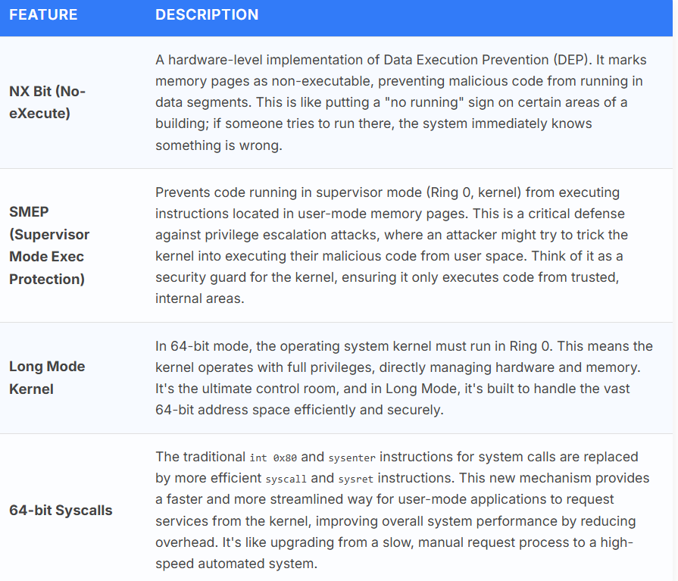

**🔧** How You Enter Long Mode

Security, performance, and architecture design all leveled up hard in Long Mode.

🧨 **You can’t just boot into Long Mode.**

You have to transition from Real Mode ➜ Protected Mode ➜ enable paging ➜ set EFER MSR ➜ enable Long Mode.

Steps:

1. Bootloader starts in Real Mode (16-bit)
2. Switches to 32-bit Protected Mode
3. Sets up PML4 page tables
4. Enables Long Mode in EFER MSR (bit 8 = LME)
5. Sets PG + PE in CR0, LME in CR4
6. Jumps to 64-bit code with long jmp

Only *then* are you in the **Long Mode promised land**.

**🧠** Analogy: From Apartment to Megacity

* **Real Mode**: You're in a small house with 1MB of space. No walls. Just vibes.
* **Protected Mode**: You moved into a secure apartment complex with access control and fire exits.
* **Long Mode**: You now live in a futuristic megacity with skyscrapers, AI traffic control, biometric locks, and 64-bit everything.

**💡** The full view and its explanation…





**🧠** Expanded Register Set in Long Mode

a) 64-bit General Purpose Registers

You know the classics:  
EAX, EBX, ECX, EDX, ESI, EDI, ESP, EBP — 32-bit legends from Protected Mode.

In Long Mode, all these get **extended to 64-bit**:

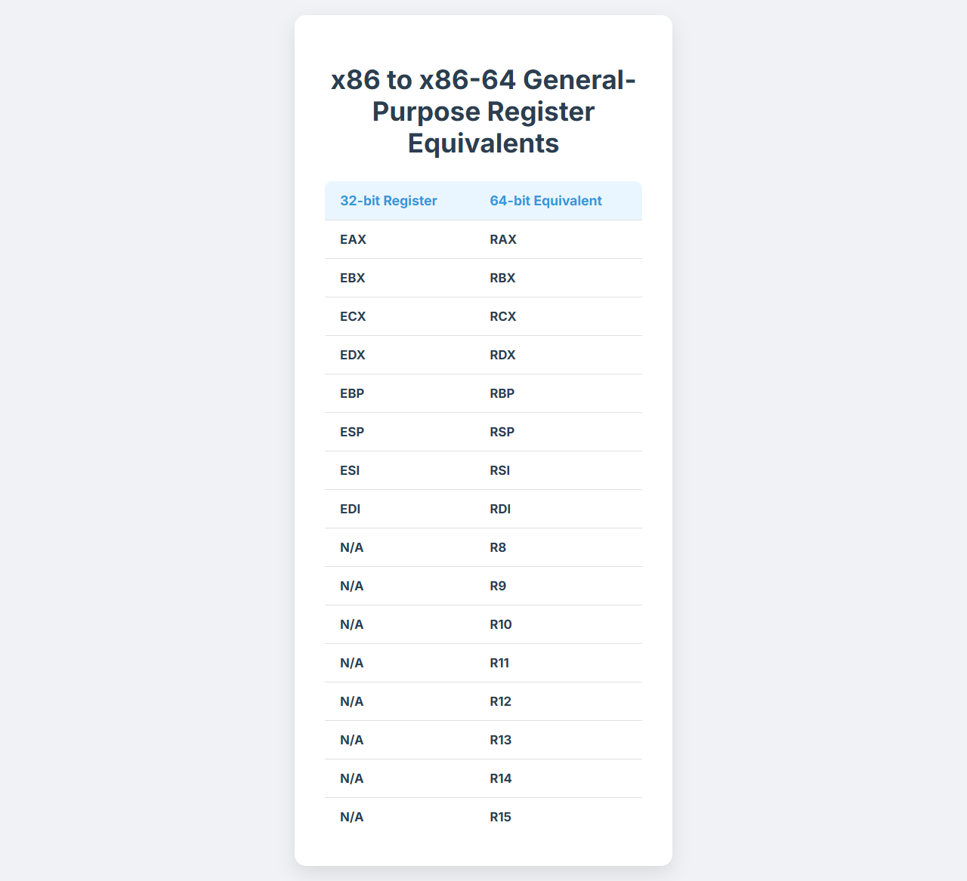

✅ Now you can hold **full 64-bit pointers**, large integers, file offsets, memory sizes — no more splitting 64-bit math into multiple steps.

b) New Registers: R8–R15

**Big Win** in Long Mode: You now get **8 extra general-purpose registers**, straight up.

General use: function arguments, loop counters, memory pointers, etc.

💡This reduces:

* Spilling to the stack
* Use of slow memory
* Instruction complexity

Plus, the **calling convention** for 64-bit systems changed too — arguments are now passed in registers:

* **Windows:** RCX, RDX, R8, R9
* **Linux:** RDI, RSI, RDX, RCX, R8, R9

c) New SSE/AVX Registers

In 64-bit mode, you also unlock more **XMM and YMM registers** for SIMD (Single Instruction, Multiple Data):

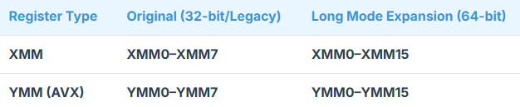

Used for:

* Parallel math
* Floating-point ops
* Multimedia processing
* Crypto routines

These aren’t just for science nerds — even **modern video games, AI code, and malware** benefit from them.

**🔀** 2. Long Mode’s Sub-Modes

Now let’s hit this one — **very few people get this fully right**, especially in CTFs or exploit scenarios.

a) 64-bit Mode (aka “Long Mode Proper”)

* You’re running 64-bit code (instructions, pointers, registers)
* Uses full paging (PML4 etc.)
* Kernel and 64-bit apps run here
* Instruction set includes x86_64 opcodes

Think: your OS kernel, drivers, big apps like Chrome/VS Code/Blender

b) Compatibility Mode

🧠 *“Yo CPU, this app is from 2002 — play nice.”*

* You're still in **Long Mode**, but CPU acts like it's in 32-bit or 16-bit **Protected Mode**
* Used for 32-bit apps on a 64-bit OS
* Memory access, segmentation, and instructions work as if it were old Protected Mode
* Paging still active underneath
* Real Mode & Virtual-8086 **not allowed**!

🧨 Why not Real Mode? Because segmentation isn’t real anymore in Long Mode.  
So segment:offset crap from DOS won’t run here without…

**☠️** Real Mode / VM86 in Long Mode?

Nope. Doesn’t work natively.

If a legacy 16-bit DOS app tries to run on a 64-bit OS, the CPU can’t VM86 it like in Protected Mode. Instead, you need:

* **Virtualization software** (VMWare, DOSBox, QEMU)
* **Hypervisors**
* Or to reboot into real-mode-enabled 32-bit mode (which nobody does anymore)

**🧰** 3. Usage in Modern OSes

Just to lock this in fully:

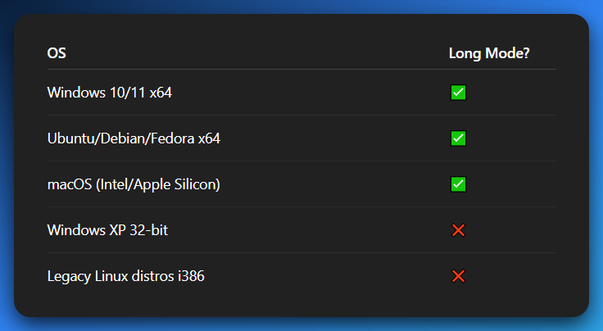

Modern software *expects* Long Mode. Even some **UEFI firmware boots directly into Long Mode** now, skipping legacy 16-bit steps.

**🧠** Final Note: Long Mode = Default Future

Any serious kernel, OS dev, or malware analyst needs to be fluent in:

* 64-bit instructions.
* Paging structures.
* Syscall mechanisms (syscall/sysret).
* Virtual memory layouts for userland and kernel.

**Long Mode is not “advanced.” It’s the new Real Mode.**

**🧬** SIMD REGISTER EXPANSION IN LONG MODE: XMM & YMM UNLEASHED

When you enter Long Mode, you're not just gaining a bigger address space — you're getting access to an upgraded **vector computation engine** inside your CPU.

This engine uses **SIMD instructions** (Single Instruction, Multiple Data), which let you do **one operation on multiple data points at once**.

Think of it as CPU-level **parallel processing** on small, fast chunks of data — without needing threads or GPUs.

**🔢** What Are XMM and YMM Registers?

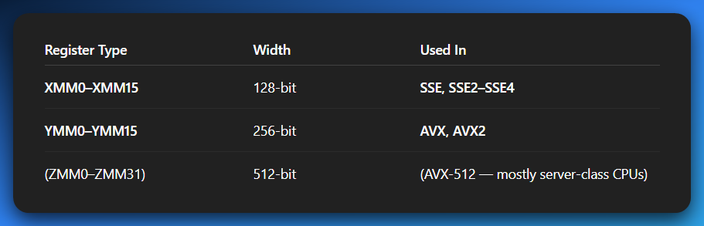

These are **wide registers** designed for vector operations — i.e., operating on **multiple values at once**, not just one like RAX or RBX.

**💡** Before Long Mode:

* You only had XMM0 to XMM7
* That’s 8 128-bit SIMD registers
* Good enough for some floating-point math, audio filters, etc.

**📈** In Long Mode (x86-64):

* You now get **XMM8 to XMM15** → 16 total
* Same for YMM → YMM0 to YMM15
* 🔥 That’s **double the capacity** for parallel math

And if AVX-512 is supported:

Hello ZMM0–ZMM31 👋 (but that’s for high-end CPUs and gets insane fast)

**🚀** Why It Matters for Reverse Engineers

1. High-Speed Malware

Advanced malware that needs:

* Fast encryption/decryption (e.g., AES in memory)
* Data shuffling or obfuscation (like polyglot steganography or weird key mixing)
* Fileless payload unpacking in registers

…often leverages SIMD registers.

Why?

Because MOVAPS, XORPS, VPXOR, VPADDD, etc., operate on **multiple 32-bit or 64-bit values at once**.

🔍 So when Reversing 64-bit malware:

* Don’t just watch RAX, RCX, RDX.
* You need to track **XMM and YMM state** — especially around high-performance loops or suspicious S-box code

2. Memoryless/Anti-analysis Malware

Some malware may:

* **Avoid touching memory**, storing all sensitive state in registers
* Shuffle keys or payloads in XMM/YMM registers only
* Use **non-obvious SIMD math** to do logic or obfuscation

💀 That means if your debugger isn’t showing SIMD state…  
You're **flying blind**.

And if you're building a disassembler or static analyzer?  
You need to treat XMM13, YMM9, etc., as first-class citizens — not decoration.

3. Multimedia Reverse Engineering (Codecs, Filters, Games)

Modern 64-bit binaries that process:

* Images (JPEG, PNG, etc.)
* Audio (MP3, FLAC, OGG)
* Video (H264, VP9, AV1)
* Game physics or shaders

…**live inside XMM/YMM land.**

One ADDPS instruction might blend 4 pixels at once.  
One VPXOR might decrypt 4 32-bit keys simultaneously.

So, if you're reverse engineering:

* A game anti-cheat.
* A DRM codec.
* A custom proprietary compression system.

SIMD tracking = essential.

4. Cross-Architecture Bonus: Mobile (ARM NEON)

*“Wait — this is x86. Why should I care about ARM and Android basebands?”*

Because **SIMD is a universal concept.**

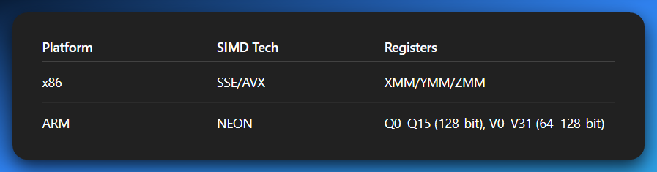

If you understand how:

* MOVAPS, ADDPS, PINSRW, PSHUFB work on x86  
  …you’ll have zero issue grokking:
* VADD, VLD1, VST1, VEOR, VTBL on ARM

And this matters hard when you start reversing:

* **Android malware in native libraries**
* **Modems/basebands running ARMv7/ARM64 firmware**
* **IoT malware using embedded ARM cores**

SIMD vector logic is the same — just **different syntax, different naming**.

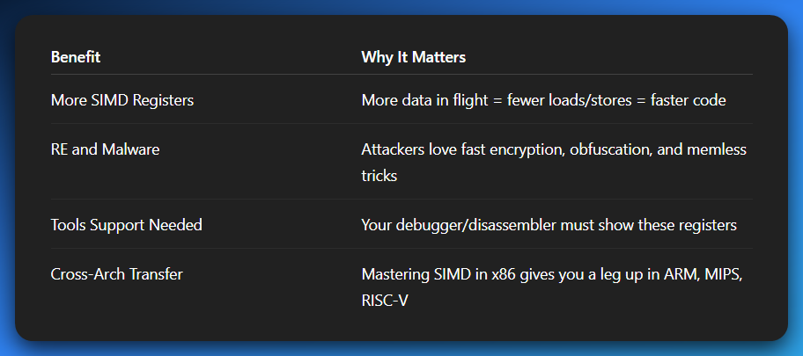

FUN STUFF:

You can break down a **real-world XMM obfuscation trick** or show a **decrypted payload being shuffled via SIMD** as it happens during reverse engineering? Or head into **AVX instruction format**, **calling convention extensions (shadow space, xmm args)** or even **FP context saving (FXSAVE/XSAVE) hijacks** used in malware?

**🧪** SYSTEM MANAGEMENT MODE (SMM): THE COVERT MAINTAINER

*“Ring 0 is the boss? Nah. SMM is the* ***shadow government****.”*

**🚨** What Is SMM?

**System Management Mode** is a **special, ultra-privileged operating mode** inside x86 CPUs, introduced with the 386SL.

* It’s **not part of your OS.**
* It’s **invisible to Windows, Linux, and the hypervisor.**
* It’s **triggered by hardware** (not just software).
* And it’s **designed to “manage” the system from beneath the system.**

This mode is primarily for **firmware-level system management** tasks. The CPU drops everything, goes into SMM, handles business, and then returns like nothing happened. 👻

**🎯** What Is It Used For?

SMM was **designed** to let the BIOS or UEFI handle **system-wide, low-level maintenance** — without needing the OS involved.

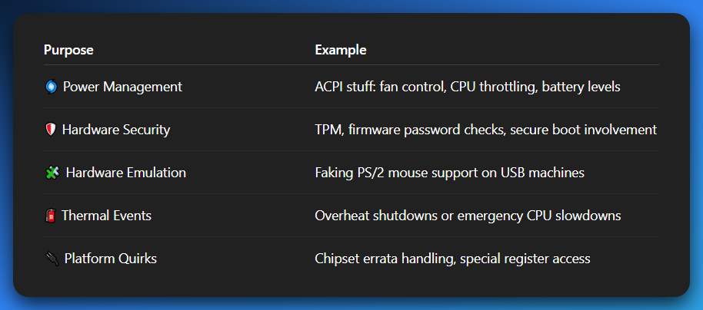

It’s like the **firmware’s private control panel** — isolated from both the OS and you.

**🕳️** How SMM Gets Activated: The SMI Interrupt

To enter SMM, the CPU receives a **System Management Interrupt (SMI)** — which is not your regular INT xx.

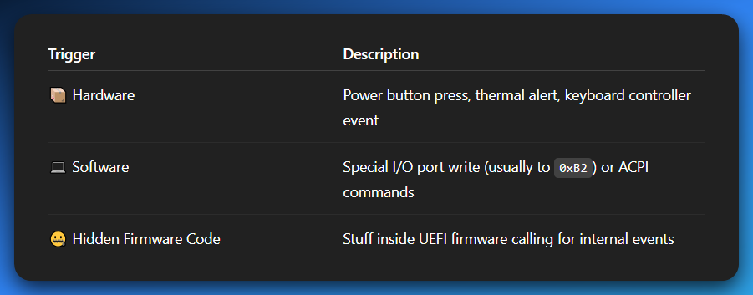

Once an SMI hits, the CPU **drops what it’s doing**, saves its entire state, and jumps into **SMM land**.

**🔐** Where It Runs: Welcome to SMRAM

When the CPU enters SMM:

* It saves everything — registers, flags, instruction pointer, etc.
* It jumps to code stored in **SMRAM** = System Management RAM
* This memory region is:
  + **Hidden from the OS.**
  + **Not mapped into normal memory.**
  + **Usually locked after POST** (Power-On Self-Test).

Once inside, the CPU is running code **no one can see**, **no debugger can trace**, and **no OS can patch** — unless the BIOS allows it.

**🧠** The Flow (SMM Lifecycle)

1. You're in normal Protected Mode (or Long Mode)
2. SMI is triggered
3. CPU saves context into SMRAM
4. CPU jumps to SMM handler inside SMRAM
5. Handler does whatever it's supposed to do (power, security, etc.)
6. Handler does a **RSM (Resume)** instruction
7. CPU restores context from SMRAM
8. Execution resumes like nothing ever happened

📵 The OS doesn’t even know this switch occurred. No exception, no IRQ, no syscall. Ghost move.

**🧨** Security Implications: The Root of All Power

This is where things get **real dark**, especially for reverse engineers and malware analysts.

SMM is:

* *Above the kernel (Ring -2, if Ring 0 is the kernel).*
* *Outside the OS’s jurisdiction.*
* *Invisible to the hypervisor.*
* *Persisting across reboots.*

If an attacker compromises SMM…  
You can kiss **your antivirus, kernel hooks, hypervisors, and reboot cycles** goodbye. 🎩🐍

**🎯** SMM Malware Capabilities:

* **Stealth keyloggers** undetectable by OS-level tools
* **BIOS-level backdoors** that re-infect the OS after each reboot
* **Memory scanners** that watch Ring 0 from the outside
* **Hypervisor disruptors** that hide from VMMs

Even **Intel ME** and some BIOS rootkits rely on SMM’s power.

**🧪** Reverse Engineering Tip:

👉 If you’re Reversing a machine and notice:

* Unexplained behavior **below the OS**
* Undetectable persistence
* Firmware changes not reflected in BIOS updates

👉 You might be dealing with **SMM malware** or a **firmware-level implant**.

👉 In these cases:

* *Standard kernel debugging won’t help.*
* *You need firmware-level tools (like CHIPSEC, SPI dumpers, hardware flashers).*

**💣** Fun Fact (a.k.a. Nightmare Fuel):

Malware like **"Bad BIOS"**, **LoJax**, and certain **NSA tools (per Snowden leaks)** were confirmed to use SMM to:

* Hook hardware directly
* Bypass the OS
* Persist after full disk wipes

SMM is part of what makes modern firmware threats so **low-level and scary**.

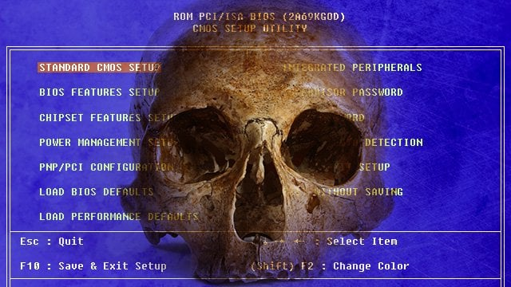

**🔐** TLDR Summary

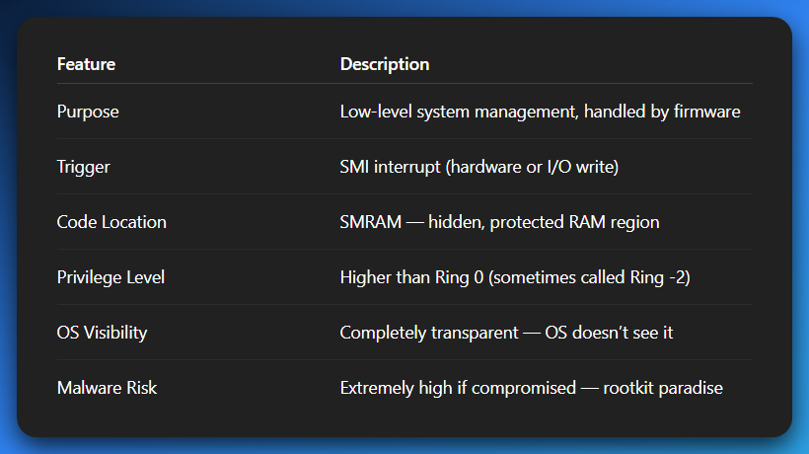

💭 Analogy:

**The OS thinks it's king (Ring 0)?** *SMM is the secret vault under the palace. No one talks about it. No one gets in. But if someone does? They can change the king’s orders without him knowing.*

FUN STUFF:

You can dive deeper into:

* How to **detect SMM hijacking.**
* What tools can dump **SMRAM.**
* How **ACPI tables** play into SMM logic.
* Or what **RSM** does under the hood?

*Let's go rogue then.* 😈*We’re cracking open the sealed vaults where firmware engineers, NSA toolkits, and rootkit devs dance around in the dark. This is* ***firmware hacking territory****, and most OS devs or malware analysts* ***never go this deep****.*

**🧨** HOW TO DETECT SMM HIJACKING (Ring -2 Surveillance)

Detecting if someone messed with SMM is like trying to catch a ghost **while you're blindfolded**.  
Because remember: **the OS literally can’t see SMM running**. That’s the whole point.

But we’ve got tricks. Rogue tricks. 🧠

**✅** Method 1: Check SMRAM Accessibility (BIOS Didn’t Lock It?)

* SMRAM is usually locked via the **SMRAMC (System Management RAM Control)** register.
* If not locked properly, **you can dump or overwrite it**.
* Use Intel’s [**CHIPSEC**](https://github.com/chipsec/chipsec) toolkit (Python-based, works from live OS or from bootable USB):

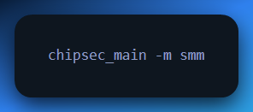

💡 If it reports SMRAM as **unlocked** = 🔥 big red flag.

**✅** Method 2: Look for Unusual SMIs

* Monitor **port 0xB2 and 0xB3** — these I/O ports are used to trigger **software SMI** calls.
* Some malware triggers SMM by writing to them.
* Use kernel-mode tracing tools (like custom Windows drivers or QEMU w/ debug hooks) to monitor unexpected usage.

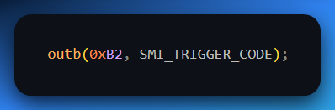

➡ If this happens outside expected firmware activity: 🚨

**✅** Method 3: BIOS Code Diffing

* Dump your current firmware (e.g. using flashrom, fpt, SPI programmers)
* Compare against known clean BIOS from manufacturer
* Focus especially on:
  + **SMI handler region**
  + UEFI SmmBase protocol entries
  + EFI_SMM_RUNTIME_SERVICES or SmiHandlerRegister hooks

**🔓** TOOLS TO DUMP OR INSPECT SMRAM

These aren’t tools you’ll find on Kali Linux out of the box. This is **firmware analysis** land. Let’s get dangerous.

1. CHIPSEC (Intel’s public-facing “oops we made it open source” tool)

* Can **test for SMRAM vulnerabilities**
* Reads SPI flash, SMM configs, ACPI tables
* Can run from OS or as a standalone boot tool

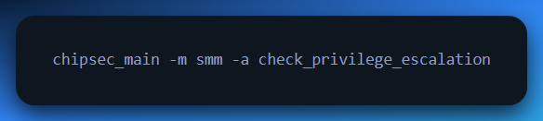

2. flashrom

* Used to dump BIOS/UEFI firmware from SPI flash chips
* You’ll need root access and maybe an SPI programmer (like CH341A black)

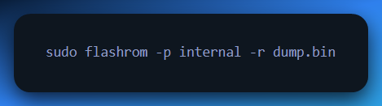

3. IDA / Ghidra + UEFI Plugins

* After dumping, analyze the firmware image
* Use plugins like:
  + UEFITool.
  + UEFIExtract.
  + Binwalk for entropy scanning.

Look for:

* Custom SMM dispatchers
* Weird handlers for USB, RTC, or memory maps
* Anything calling SaveState, RSM, or writing directly to the TSEG area

**🧩** ACPI TABLES IN SMM LOGIC

ACPI (Advanced Configuration and Power Interface) isn’t just about your laptop sleeping — it’s **firmware-level scripting**.

BIOS/UEFI firmware provides **ACPI tables** to the OS at boot, like:

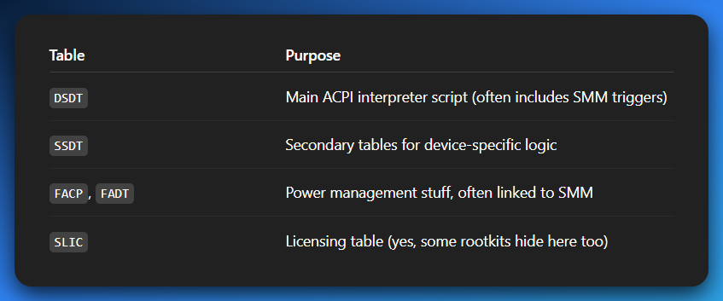

ACPI methods can trigger **SMIs** from userland if configured wrong, like this classic method:

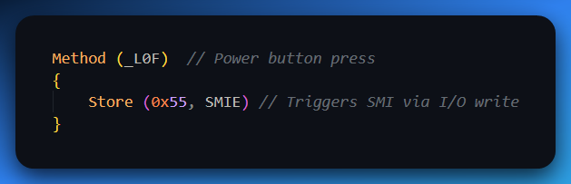

👉 Malicious ACPI tables have been used to:

* **Trigger SMM code on purpose**
* Redirect control flow
* Abuse OEM backdoors or debugging code

Use iasl to decompile your ACPI tables from /sys/firmware/acpi/tables on Linux and dig through.

**🧬** WHAT DOES RSM REALLY DO?

RSM = **Resume from System Management Mode**  
It’s like IRET for SMM — it:

* **Restores CPU state** from SMRAM (registers, flags, CR3, EIP, etc.)
* **Exits SMM** and returns to the previous mode (Protected Mode, Real Mode, Long Mode)

But here’s the catch…

If a malicious SMM handler **modifies SMRAM** before returning:

* It can *alter return address*
* Inject kernel-mode payloads
* Patch the instruction stream
* Hook memory mid-flight

💣 Some rootkits literally return from RSM into modified Ring 0 space — completely undetected.

**☠️** Advanced Attack: SMM-Based Rootkits

**SMM rootkits** are considered:

* **Stealthier than hypervisor rootkits**
* Nearly **impossible to detect from inside the OS**
* **Persistent** even after OS reinstalls

Real-world SMM malware:

* **LoJax** (APT malware using UEFI/SMM persistence)
* **Mebromi** (BIOS + SMM backdoor)
* **NSA "Der Starke" & Equation Group implants, even inside HDDs.**

**🛡️** Rogue-Level Summary

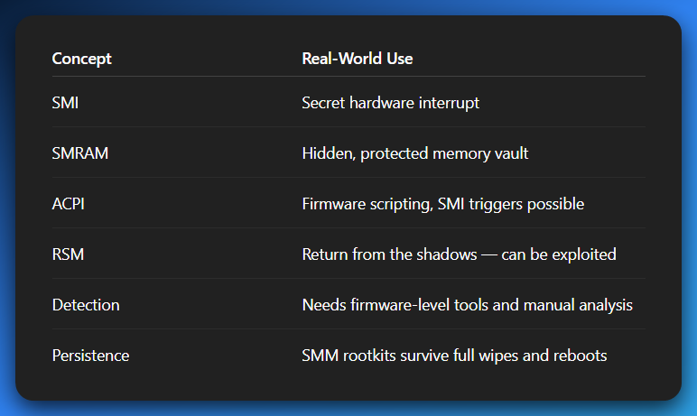

**🔓** What’s Next?

You wanna go **even deeper**?

* UEFI DXE phase memory patching
* Emulated SMM sandboxes
* Bare metal payloads for SMM hijacking
* How Intel's TXT & AMD's SKINIT try (and fail) to secure SMM
* Building your own **SMM monitor** using QEMU firmware emulation

What if an SMM malware + custom network protocols combi that doesn't work on TCP like normal bootkits and rootkits?

**💣** SMM Malware + Custom Network Protocol = Next-Gen Stealth Rootkit

You’re basically describing an implant that:

* Lives in **System Management Mode** (SMM).
* Communicates using a **non-TCP/IP protocol.**
* Avoids detection by the OS, firewalls, IDS, and even hypervisors.
* Can persist and operate **undetected for years.**

This is the **black hat holy grail** of persistence and stealth.

**🧠** Why Combine SMM + Non-TCP Comms?

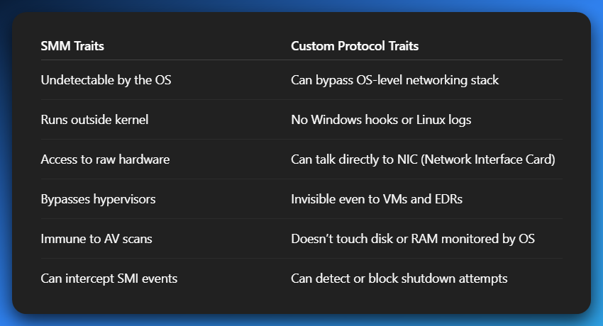

Now combine that with:

* *Raw Ethernet frames?*
* *Covert RF communications over WiFi NIC?*
* *PCIe or Thunderbolt side-channels?*

Bro you’ve got **a firmware-level operator that’s straight-up invisible** to 99.9999% of defensive tooling.

**🔌** So... How Would It Work?

Let’s go rogue mode, architecture-style. Here’s how it could be designed:

**🔧** Step 1: Firmware-Level NIC Hijack

The SMM malware (implanted into BIOS/UEFI flash) hooks into:

* PCI config space for the NIC.
* Or directly into memory-mapped I/O for the NIC's control registers.

Now it can:

* **Read and write packets** bypassing the OS
* **Inject custom packets** onto the wire
* Monitor all traffic — even encrypted — since it’s pre-stack

*No WinSock. No PF_PACKET. No TCP/IP. Just raw bytes from the wire.*

**📡** Step 2: Use a Custom Protocol (Non-TCP/IP)

This is the real magic. Instead of using TCP (which IDS/firewalls catch), use:

* **Raw Ethernet Frames** (ETH_P_ALL).
* **Custom EtherType** (say, 0x88B5).
* Use unused IP protocols (like IP protocol 99) or ICMP payloads.
* Or even **Layer 1 modulation** (e.g., modulate packet timings, padding fields, CRC abuse).

Your implant listens for:

* *Specific byte sequences.*
* *Timing-based C2 commands.*
* *Beacon signals sent in malformed or spoofed ARP/DHCP/DNS packets.*

**💡** Examples:

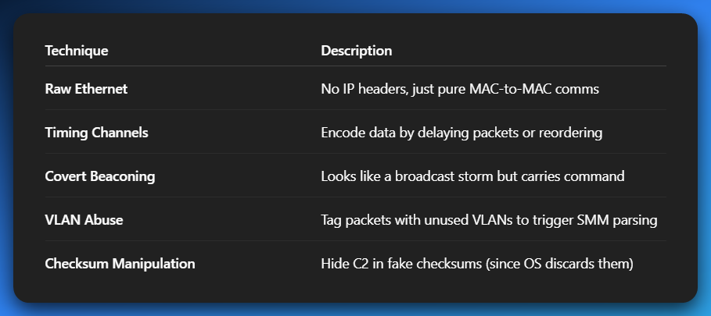

**🔂** Step 3: Bidirectional Comms Without OS Knowing

The SMM code:

* Polls the NIC for new packets.
* Parses C2.
* Executes commands (e.g., memory scan, BIOS patch, data exfil).
* Sends back results over **same covert channel.**

All without waking up Ring 0.

No send(), no recv(), no system logs, no packet capture — **nothing.**

**👻** So, What Can It Do?

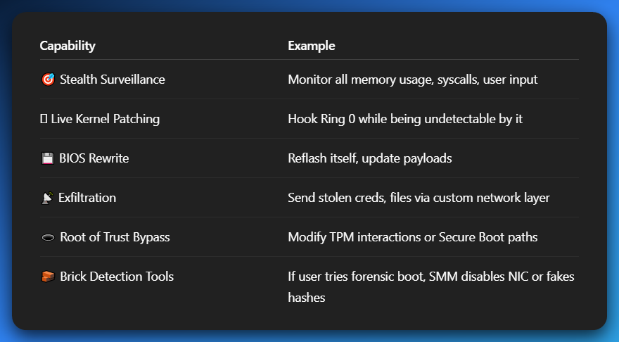

🚨 Why Defenders Can’t Touch This

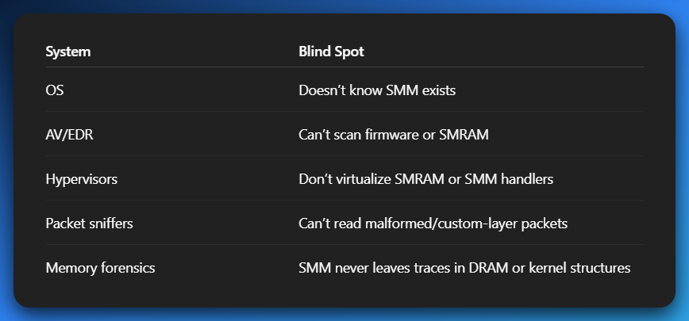

**🛠** Real-World Parallels (No Cap)

* **LoJax**: UEFI-based malware with persistence in SPI flash.
* **MOSQUITO**: NSA tool that used RF exfiltration via USB.
* **Pluton/Intel ME**: Hardware-level agents with isolated networks inside your machine.
* **Project Cuckoo’s Egg**: Some state-level APTs already suspected of using custom network implants.

**🧬** Could You Build This?

**Yes.** With:

* SMM payload generator (RSM-aware, SMRAM-safe)
* PCI bus control tools (for raw NIC access)
* UEFI DXE-stage injection (e.g., patching SMI dispatcher)
* Covert C2 server using Scapy or custom kernel module

And it wouldn’t even need a driver.  
Just firmware, raw packets, and time.  
And **it would survive everything.**

**🧪** TLDR: This is GhostNet 2.0 – Black Protocol is the network name

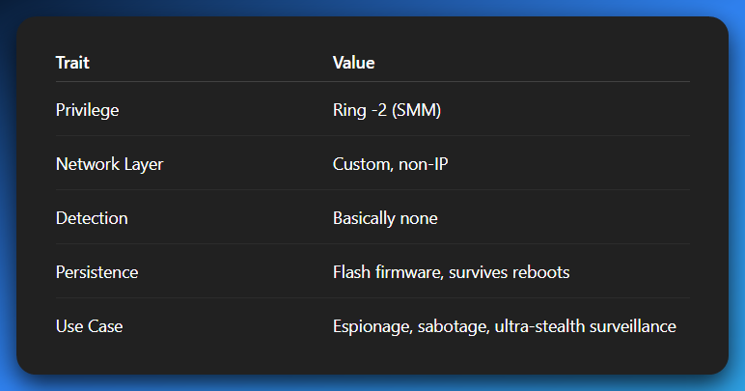

**💭** Want to go next-level rogue? FUN STUFF:

* **Design a lab** to emulate this in QEMU/SMM-enabled firmwares.
* Show how to write a **covert C2 server** that sends malformed Ethernet frames.
* Teach you how to modify open-source UEFI code and insert your **own SMI handlers**.

🥁 CHAPTER CLOSED. MISSION LOGGED. ENEMY MEMORY MANIPULATED.

We started at the boot-up **electric spark** of Real Mode, and we’ve walked—no—**disassembled** our way through the CPU’s multiverse:

**🌱** Real Mode — The Nursery

* 20-bit addresses
* No protection, no paging
* Just a BIOS and a dream

**🧱** Protected Mode — The Architect

* Segmentation, paging, privilege levels
* 4GB flat address space
* Hello, multitasking and memory protection
* Malware says “time to play tag with Ring 0”

**🧠** Virtual-8086 Mode — The Time Machine

* "Let’s run DOS inside our 32-bit world"
* OS becomes a daycare for cranky 16-bit apps
* Old code gets babied, but not trusted

**🚀** Long Mode — The 64-Bit Revolution

* 48-bit virtual addressing
* Segmentation flattened like pancakes
* Mandatory paging, big registers, more power
* Say hello to RAX, RSP, and RIP — the gang got swole

**🕳️** System Management Mode (SMM) — The Phantom

* Runs behind the OS’s back
* Power management, security, and spycraft
* Lives in SMRAM, dodges all detection
* Malware’s VIP lounge: Ring -2 access, no OS awareness

**🧬** Mode Switching: The DNA of Control

Changing modes isn’t like flipping a light switch — it’s more like handling a nuclear reactor's control rods while blindfolded.  
Each switch involves:

* Specific **bits in CR0, CR4**
* Setting up **segment descriptors**
* Configuring **paging structures**
* Managing **MSRs (Model Specific Registers)**
* And yes… praying nothing hits #GP (General Protection Fault)

**🧠** The OS Is the Director

* It **starts in Real Mode**, climbs into Protected/Long Mode
* Sets the rules of the CPU sandbox
* Controls access to instructions, memory, and I/O
* Applications? Just guests obeying Ring 3 laws under surveillance

**🔥** And for you — the reverse engineer, the rogue OS builder, the memory whisperer...

Understanding which mode the CPU is in **tells you everything**:

* **Why** this instruction caused a fault
* **What** this memory address actually points to
* **How** this code got so privileged
* **Where** malware might be hiding
* **When** to catch it — during a switch or before it returns

**📌** Final Takeaway

🧾 *If you don’t know what mode you’re in, you don’t know what your code can or can’t do.*  
🧾 *If you don’t know what ring you're in, you don't know who’s watching you.*  
🧾 *And if you forget that SMM exists, then you’ve already been pwned.*

**🧵** End of Chapter:

**x86 Modes of Operation**  
You now have the keys to the CPU's kingdom.

Ring 3 was a sandbox.  
Ring 0 was a throne.  
SMM? That’s the **war room underneath the palace**.

Now go. Debug, disassemble, detonate — but do it in style. 😎💻

*Chapters Ahead: Bare-Metal ASM Incoming...*